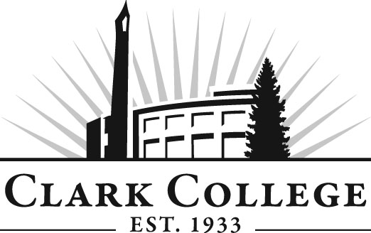

MECHATRONICS ADVISORY COMMITTEE

MINUTES
Tuesday, October 26, 2010
5:30 PM – 7:00 PM
Columbia Tech Center, Room 106

Members Present Representing
John Smith Lab-Volt Systems, Inc.
Sean Cain Maxim Integrated Products
Anne Koering
Chris Taylor, Vice Chair Daimler Trucks North America
Zeb Hallmark, Committee Chair Linear Technology
Mike Wilson Andersen Dairy

Members Absent
Dan McAllister Vestas America

Clark College
Chris Lewis Department Head/Mechatronics Professor
John Reynolds Adjunct, Mechatronics
Genevieve Howard Dean, Workforce & CTE
Dedra Daehn Director, Academic Services & Innovation
Suzanne Thayer Program Coordinator, Career Services
John Maduta Advising Divisional Manager-Professional
Technical Programs

Meeting was called to order by Mr. Zeb Hallmark, Committee Chair, at 6 PM with introductions.

Review of the Minutes of the Previous Meeting:
The minutes of the previous meeting were reviewed and a motion was made to approve the minutes as written. The motion was seconded and unanimously approved.

Advisory Business:
Ms. Dedra Daehn reminded the members of the upcoming Advisory Recognition Reception on November 3rd.

Work Plan:
Professor Lewis said that the Outcomes and Assessment in the Work Plan is ongoing. Another item on the Work Plan is the Foundation Grant Proposal. The Outcomes and Assessments that was due in Spring of 2011 has been met and now, other Outcomes and Assessments will be added with the goal being ongoing.

Ms. Daehn talked about the 3-5 year equipment plan that Instruction is requesting each of the departments to develop. Dean Howard talked about the benefits of having the equipment needs outlined so that when the Foundation grants or Foundation allocations come up, the departments will have the priorities completed.

Adding Safety Specific Courses:
Professor Lewis said there are safety aspects of each course but that he was questioned about specific safety training courses for each. He asked the members what types of safety training their respective companies have for the employees. One member said lock-out/tag-out, another said crane operations safety, pneumatic hazards, eye wash stations, basic hazmat certification, etc. He said he was looking into a safety training class that he can include in the program that will be more general.

New Member Information:
Professor Lewis said that he invited Mr. Mike Wilson to come and sit in on a meeting to see if he wanted to join the committee. Mr. Wilson said it was effective for his employees to attend Clark for a summer session of training on some of the specific equipment.

Mr. Hallmark asked the committee members how to recruit management people as they represent companies that can provide wonderful opportunities for graduates to find employment when they finish with the program.

Program Equipment Needs:
Professor Lewis said most of the equipment has been funded for his program. He said if he is asked, he would like to request more business software and system management software. The system currently is adequate for the classes now but if he ever wants to expand, then he will need more software. He showed slides of the new manufacturing system that is coming in from Spain.

Next Meeting:
January 24, 6:00-7:30 PM

Meeting adjourned at 7:00 PM.

Another member asked Professor Lewis for an update on enrollment. Professor Lewis said that currently there were 7 students enrolled. He said he lost a couple after the start of the fall quarter, so currently there are 7. Ms. Koering is facilitating electronics course.

