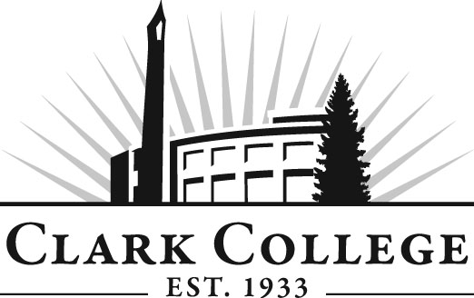

MECHATRONICS ADVISORY COMMITTEE

MINUTES
Tuesday, January 24, 2012
6:00-7:30 PM
Columbia Tech Center, Room 206

Members Present Representing
John Smith Lab-Volt Systems, Inc.
Chris Taylor, Vice Chair Daimler Trucks North America
Zeb Hallmark, Committee Chair Linear Technology

Members Absent
Dan McAllister Vestas America
Sean Cain Maxim Integrated Products
Mike Wilson Andersen Dairy

Clark College
Chris Lewis Department Head/Mechatronics Professor
John Reynolds Adjunct, Mechatronics
Jeremy Neyens Adjunct, Mechatronics
Larry Smith Instructional Tech
Genevieve Howard Dean, Workforce & CTE
Dedra Daehn Director, Academic Services & Innovation
John Maduta Advising Divisional Manager-Professional
Technical Programs

Mr. Zeb Hallmark, committee chair, called the meeting to order at 6:15.

Approval of the Minutes of the Previous Meeting:
The minutes were reviewed and a motion was made to approve the minutes. The motion was seconded and unanimously approved.

Advisory Committee Business:
Ms. Dedra Daehn asked the members to be thinking about what time of day would be best for holding an advisory appreciation reception and that a survey will be sent out to the members to see what the most popular response would be.

Ms. Daehn also said she has started doing new member orientation for the new members who are recruited to the committee and that since Mr. Mike Wilson is new, she will schedule an orientation with him before the start of the next meeting. New staff and faculty are also welcome to attend.

Work Plan:
Ms. Daehn also brought up the Mechatronics Work Plan and asked the committee to review each of the items and give any updates. Some of the deadlines were revised.

Open House:
Professor Lewis invited the members to come and visit the open house tomorrow at either 10:30 AM or 6:00 PM and that it would be a good opportunity to visit the lab and see the equipment that have been installed recently.

The next possible open house is in the spring but Professor Lewis did not have a date yet.

Foundation Funds Request:
Professor Lewis said he has one piece of equipment that has not been requested yet and that is the add-on to the mechanical training system. This is the only item he is in need of right now. He felt strongly that the Foundation would approve this purchase as he has had strong enrollment in the program to support this addition.

Changes to the Electronics Courses:
Professor Lewis said that he is working with the staff and administration to try to come up with a better hands-on approach in fundamental electronics course. He wants to lighten the course loads and the members were very agreeable on the point of increasing hands-on for the students. He said he is going through the process of reducing the credit load per electronics course from 6 credits to 4 credits each.

Update on Industry Training:
The training at Anderson Dairy has ended and they were so impressed that Anderson Dairy is paying one employee’s tuition to complete the Mechatronics Program. SEH is also interested in some training and Chris formatted a training proposal to them. He is waiting to hear back from them.

Defense contract company in Stevenson is also very interested in mechatronics program and wants him to come out and talk to them.

Frito Lay also has 25 managers here at CTC for a monthly managers’ meeting. They all visited the Mechatronics lab.

Inactivate the Manufacturing System Maintenance Technology Degree:
Dean Genevieve Howard is asking the committee members to vote on approving discontinuing the Manufacturing System Maintenance Technology Degree. This was the old electronics course and some of the classes will be taken off line, and although some of the classes will remain, she is doing away with the degree. There are no students in this degree path at this time and the dean said this was just a housecleaning item. This request for approval will be sent out electronically to the other members.

Professor Lewis asked the members to visit the lab before they leave this evening.

Next Meeting:
June – last week of classes. Professor Lewis said there are 7 students from the Mechatronics Program who are ready to graduate this spring. The members were all favorably impressed. Dean Howard also added that Professor Lewis has really put in a lot of effort to introduce the Mechatronics program out into the community to increase enrollment in the program. He presented this to the Board of Trustees in October or November last fall.

Meeting adjourned at 7 PM.

