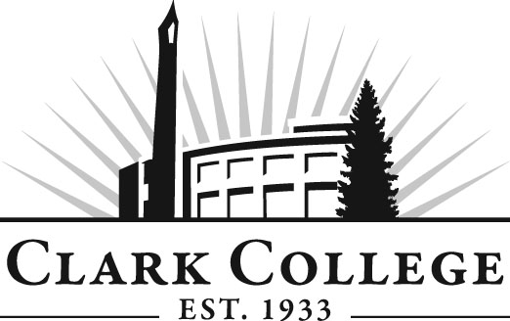

MECHATRONICS ADVISORY COMMITTEE

MINUTES
Tuesday, January 22, 2012
6:00-7:30 PM
Columbia Tech Center, Room 206

Members Present Representing
Zeb Hallmark, Committee Chair Linear Technology
Chris Taylor, Vice Chair Daimler Trucks North America
John Smith Lab-Volt Systems, Inc.
Nirav Sheth SEH America

Members Absent
Mike Wilson Andersen Dairy

Clark College
Chris Lewis Department Head/Mechatronics Professor
John Reynolds Adjunct, Mechatronics
Jeremy Neyens Adjunct, Mechatronics
Larry Smith Instructional Tech
Genevieve Howard Dean, Workforce & CTE
Dedra Daehn Director, Academic Services & Innovation
John Maduta Advising Divisional Manager-Professional
Technical Programs
Andreana DiGiorgio Advisory Committee Coordinator

Mr. Zeb Hallmark, committee chair, called the meeting to order at 6:05.

Approval of the Minutes of the Previous Meeting:
The minutes were reviewed and a motion was made to approve the January 22, 2012 minutes. The motion was seconded and unanimously approved.

Advisory Committee Business:
All of the committee rosters are updated at each meeting to help us ensure that the employer/employee ratio is 50% for each group. The State of Washington requires that this information is tracked. The state defines an employer as someone with hiring and firing power.

Dedra Daehn reported that the advisory committee agenda format has been changed. The main format change reflects a time column, which places an amount of time to be used for each agenda item with the majority of the meeting focused on the committee’s work plan. Clark College acknowledges and appreciates the time the industry members take out of their schedules and the change in the agenda format is one way to more effectively use the members’ time.

Ms. Daehn reported that this year a new online training for new committee members is now in place. This training can be done at their convenience and gives them an overview of the committees and their responsibility as an advisory member.

Ms. Daehn also spoke briefly about Perkins funding. Last spring the college was awarded $575,808 in Perkins funding. It is federal finding that comes through the state and supports Clark’s career and technical programs. The primary focus of using these funds is to prepare students for the workplace, help them improve their technical skills as well as their academic skills.

Another source of funding available to Clark College is the Worker Retraining funds received from the state. The amount of money awarded for 2012-13 was over $1,000,000. This funding is used to support and provide education, training, and career services for dislocated and unemployed workers. Students coming in to Clark who have been laid off or dislocated may be eligible for financial aid and other monetary support because of the Worker Retraining program. These moneys can also support some of Clark’s adjunct faculty and equipment needs.

It was time for the election of a new committee chair and vice chair. Zeb Hallmark and Chris Taylor were re-elected to chair and vice chair, respectively, with unanimous approval by the committee.

Director/Division Chair Report:
Mechatronics instructor and Department Head Chris Lewis reported that enrollment is way up with two first-year starts; one in the fall and another in winter. There are currently seven second-year students in the program. Six students graduated in June 2012.

Chris also reported that there is new training in place for students with SEH America. New advisory member Nirav Sheth, a manager at SEH has helped get this training off the ground. In the last month and a half, 15 students have been able to take advantage of this training.

Dean Genevieve Howard reported that the college is looking at a new millwright certificate, taking portions of other programs, such as welding, machining, and mechatronics and then combining them into this new certificate.

Chris asked the committee if they would be involved with the Capstone project. Basically he needs the committee members to grade the presentation and provide feedback.

Work Plan:
Dedra explained to the committee that the work plan should be updated at every meeting. The state requires the committees to have an annual work plan. After some discussion, it was agreed that the Capstone project, with committee input, would be added.

Chris asked the committee to consider making Clark College a regional training center for FANUC Robotics. Students would benefit from this if they could obtain their National accreditation Certificate. Chris believes industry would also benefit by hiring new employees with this training and accreditation. The cost would be around $35,000. These dollars will be requested from the Foundation as soon as the Foundation has a request deadline in place.

Dean Howard recommended Vision 2020 be added as an ongoing work plan item.

New Business:
Chris and Genevieve discussed a number of potential curriculum changes to the program. Chris reported that he has been working on realigning the course offerings. This new proposed curriculum will give students tangible skills and make them highly marketable. The proposed changes are as follows:

- Addition of a Certificate of Achievement in Instrumentation Automation & Control
- Addition of a Certificate of Achievement in Mechanical Automation
- Increase MTX 123 to 3 credits
- Change MTX 217 from Mechatronics 3 to Mechatronics 2
- Change MTX 260 from 6 credits to 3 credits
- Change ELEC 101, 102 and 121 to 3 credits and use the MTX prefix
- Delete MTX 215, ELEC 101, 102 and 121

A motion was made to approve the above curriculum changes as a block approval. The motion was seconded and the committee unanimously carried the motion.

Next Meeting:
The next meeting was scheduled for Tuesday, May 14, 2013 at 6 p.m.

Meeting adjourned at 7:10 p.m.

