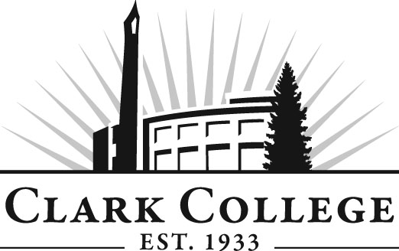

FITNESS TRAINER ADVISORY COMMITTEE

MINUTES
Wednesday, May 2, 2012
2:00-3:30 PM
OSC 204

Members Present Representing
Louise Allen, Vice Chair Marshall Community Center
Nick Jackson 24 Hour Fitness Center
Steven Phillips West Coast Fitness
Alex McMillan ALX Fitness & Fitness Profit Solutions
Kara Carlson Northwest Personal Training
David Hart Touchmark

Members Absent
Adrienne Sousa Northwest Women’s Fitness
Denise Croucher, Committee Chair Lacamas Swim and Sport Center

Clark College
Lisa Borho Department Head & Professor,
Fitness Trainer
Robert Maves FT Instructor
Dedra Daehn Director of Academic Services & Innovation
Shelley Ostermiller Health Occupations & Education Advising,
Divisional Manager

Meeting was called to order at 2:10 PM by Professor Lisa Borho.

Review of the Minutes of the Previous Meeting:
A motion was made to approve the minutes as written. The motion was seconded and unanimously approved.

Announcements/Feedback:
Professor Borho said the Triathlon is scheduled for Friday, June 15, 2012, at the Lacamas Swim and Sport Center. She said she will need volunteers at the Triathlon. Ms. Allen asked for a reminder email asking for volunteers as she will check with her staff.

Internship Fair:
Professor Borho asked the members for their opinion of the internship fair. She said they tried to match top students to top employers. There were up to 20 students looking for internship sites. There were 12 to 14 employers who responded to the fair as potential internship facilities.

Professor Borho said she met with new fitness centers in the areas to see if students could be hired as interns at these new locations.

Ms. Kara Carlson gave her review of the internship fair. She said she was looking for about 4-5 interns but only found one. Professor Borho said she will review the selection process of interns because the process did not go well this year. Mr. Phillips suggested it might be worthwhile for the students to visit the different fitness centers to get an idea before the fair.

Professor Borho said that Concordia has a 1 credit intern class where students do everything to prepare for an internship – write resumes, put together portfolios, etc., and she asked what the committee thought about Clark coming up with a class like that. Would it be helpful to have such a class so students can prepare for internships? They could learn to put together cover letters, photo business cards, letter to the internship sites, etc. Professor Borho said she will think about possibilities for a while.

Professor Borho said part of the Work Plan discussed at the last meeting was to ask if the program should be changed so there is limited entry into the program.

Instructor Maves said some students come into the program not knowing anything about anatomy. He also said some percentage of students who do not know how to study, don’t study outside of class, they also don’t know how to do research.

FT-150 is Fundamentals of Fitness and the students told Professor Borho that this should be a pre-req for students coming into the fitness program. Also needed is a motor learning section. Need to learn what lessons plans were. Should have a mandatory swim class.

Tablet Technology:
Professor Borho said she got a grant to look at e-tablets. She asked if e-tablets should be mandatory. If designated as mandatory, Financial Aid would apply for the purpose of the e-tablet. iPads –used- cost $200. The tablets will be highly recommended for this fall and mandatory next year.

Next Meeting Date:
There will be a meeting in August.

