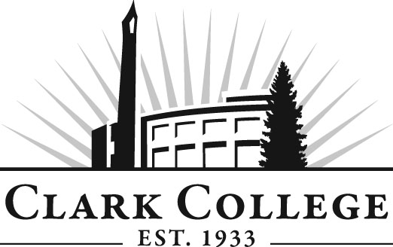

EARLY CHILDHOOD EDUCATION
ADVISORY COMMITTEE

MINUTES
Friday, May 11, 2012
12:00-1:30 PM
Oliva Child & Family Services Center

Members Present Representing
Andrew Forshee Portland Community College
Margaret Grant Children’s Home Society of Washington
Karen Peterson WSU-Vancouver
Margaret Selway, Vice Chair Educational Opportunities for Children &
Families
Darcy Taylor Department of Early Learning
Jacquelyn Keith Vancouver Library
Debra Shope, Committee Chair SW Washington Assoc. for Ed. of Young
Children
Ebie Mountford Country Friends Child Care Center

Members Absent
Jodi Wall ESD #112
Kristin Johnson ESD #112
Lora Whitfield Albina Head Start
Holly King Educational Opportunities for Children &
Families

Clark College
Laurie Cornelius Director, Child & Family Services
Debi Jenkins Faculty in ECE and Psychology, Department
Head
Sarah Theberge Faculty in ECE/Family Life
Michelle Mallory Family Life Coordinator, Faculty in
ECE/Family Life
Kay Beauliere Coordinator, ECE/Family Life Faculty
Miles Jackson Dean, Social Science & Fine Arts
Dedra Daehn Director of Academic Services & Innovation

Meeting was called to order at 12:14 PM by Ms. Debra Shope, Committee Chair.

Professor Theberge announced that 28 students will be presenting their portfolio on May 31st so she invited advisory members to come and see them on the 31st.

Review of the Minutes of the Previous Meeting:
A motion was made to approve the minutes as written. The motion was seconded and unanimously approved.

Advisory Committee Business:
Ms. Dedra Daehn asked for work plan items for 2012-2013. She reviewed the current 2011-2012 items with the committee. IDI will be the focus on the Work Plan for the next year. Reggio Exhibit – the ECE staff and faculty have discussed the Reggio Exhibit to great lengths and recommended that all the members and people in the ECE field go and visit the exhibit.

2012-2013 Curriculum:
Item 3 should remain on the Work Plan to allow members to visit the exhibit and report on their impressions this fall.

ECE I-Best:
Director Laurie Cornelius said they are in the process of hiring an instructor for ECE I-Best. She said they had a large pool of applicants. Professor Mallory is the faculty to contact if there is interest in the I-Best. She said she is at Town Plaza every Thursday at 11 AM and 4 PM to discuss more information on the I-Best.

Statewide Degree and Certificate:
Professor Theberge explained what is needed to meet requirements in the Washington Career Lattices for early care and education professionals. She said she would like advisory committee approval of this certificate requirement. Currently ECE AAS degree requires 102-103 credits. She asked the committee members to look at the three certificates and consider approving the proposal.

*Asterisks identify courses that meet the requirements for this certificate.

ECE Current  I-BEST |  | Proposed ECE  I-BEST
1st Quarter (summer,winter) |  | 1st Quarter  (summer, winter)
ECE 124 Guiding | 3 credits | ECE& 105 Intro to ECE * | 5 credits
ECE 114 Environments | 3 credits | ECED&170 Environments | 3 credits
ECE 208 Early Language | 2 credits  *will be dropped in proposed certificate
ECE 199 Cooperative  Work Experience | 2 credits  *will be dropped in proposed certificate | ECE&120 Practicum * | 2 credits
ABE/ESL/GED | 5 credits | ABE/ESL/GED | 5 credits
Total | 10 ECE credits  5 support credits | Total 10 ECE credits  5 support credits
2nd quarter  (Fall, Spring) |  | 2nd quarter  (Fall, Spring)
ECE 121 | 4 credits | ECE& 107 Health, Safety and Nutrition * | 5 credits
ECE 111 (CPR, First aid) | 1 credit  *will be dropped from the certificate | EDUC& 130 Guidance | 3 credits
ECE 103 Child, Nutrition and Health | 3 credits
ABE/ESL or GED | 5 credits | ABE/ESL or GED | 5 credits
Total | 8 ECE Credits  5 support credits | Total 8 ECE credits  5 support credits
Total I-BEST Certificate of Achievement Initial Child Care  *fulfills 12 credit State  Initial Certificate | ECE 18 credits | ECE 18 credits

ECE Math Class:
Professor Jenkins felt the students need at least a basic knowledge of how to develop graphs, and do simple algebra.

A motion to approve the certificates for Washington Career Lattices as presented. The motion was seconded and unanimously approved. Director Cornelius said next step will be amending the Concordia agreement and the I-Best certificate.

Ms. Shope announced that the Week of the Young Child was April 22nd. It sponsored a variety of people and invited them to the mall, and she said they had a steady stream of visitors all day long.

Next Meeting:
Friday, November 2, 2012 from 12:00 to 1:30 PM.

