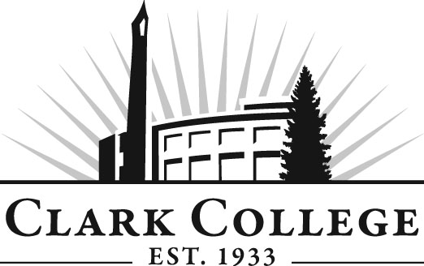

EARLY CHILDHOOD EDUCATION ADVISORY COMMITTEE

MINUTES
Friday, February 8, 2013
11:30 am--1:30 pm
Oliva Child & Family Services Center

Members Present Representing
Debra Shope, Committee Chair SW Washington Assoc. for Ed. of Young
Children
Margaret Selway, Vice Chair Educational Opportunities for Children &
Families
Margaret Grant Children’s Home Society of Washington
Kristin Johnson ESD #112
Lora Whitfield Albina Head Start
Ebie Mountford Country Friends Child Care Center
Karen Peterson WSU-Vancouver
Jacquelyn Keith Vancouver Library
Kristi Baker SWCCC/ESD 112

Members Absent
Andrew Garland-Forshee Portland Community College
Darcy Taylor Department of Early Learning
Katrina Alderman Childcare Resource & Referral

Clark College
Laurie Cornelius Director, Child & Family Services
Debi Jenkins Department Head/Division Chair Behavioral
Sciences, Faculty in ECE and Psychology
Kathy Bobula ECE Faculty/Psychology
Michelle Mallory Family Life Coordinator & Faculty
Sarah Theberge ECE Curriculum Lead/Faculty in ECE/Family Life/
Kay Beauliere Coordinator Early Intervention, ECE/Family
Life Faculty
Miles Jackson Dean, Social Science & Fine Arts
Sarah Weinberger Career Services
Andreana DiGiorgio Secretary Sr., Advisory Committees

The meeting was called to order at 11:46 p.m. by Committee Chair Debra Shope, and introductions were made.

Review of the Minutes of the Previous Meeting:
After some discussion regarding EDUC& 150 as satisfying the Human Relations requirement of the Associate of Applied Science degree, as well as any certificate requiring human relations, a motion was made to approve the minutes as amended. The motion was seconded and unanimously approved.

Office of Instruction Update:
Dean Miles Jackson gave the OOI update. He informed the committee of a new tool the college is utilizing called the Virtual Notebook that collects statistics and other information on all of the programs at Clark. Miles said that staff and faculty can use this tool to find out information about a program including, completion rates, success rates, enrollment and outcomes. This information will be more accurate when the current registration coding of students is corrected. Department Head Debi Jenkins would like the college to enhance the current software and technology so that students can be tracked more closely. Other colleges track students from the day they begin to when they graduate. The Virtual Notebook is only available through the Clark College intranet; however, if the committee wants to look at this information it can be made available to them.

Dean Jackson asked the committee to think about what the Early Childhood Education program will look like in the year 2020. He said not to think about budget constraints. He asked the committee to come back to the next meeting with their ideas. This item will be put on the agenda for the spring meeting and it will be an ongoing work plan item.

Dean Jackson informed the committee that there are updated labor market reports in case they would like to take a look at them.

Division Chair Report
Director Laurie Cornelius reported that the Early Achievers program is coming along very well. There has been input form faculty and students and successes have been noted. Nine students are taking classes this quarter. Classes started in January and prior to that, students were very busy obtaining the Pell grants available to them. There was also Early Achievers Opportunity Grants available. These needed to be completed and approved before the start of classes. Eight students are waiting to start in spring quarter. Clark is one of nine pilot colleges to utilize these Early Achievers Grants. Hardship dollars are also available to the students.

Work Plan
The committee was asked by ECE Professor Sarah Theberge to have a discussion to “wordsmith” the current outcomes requirements. She recommended they be clear and concise, but not convoluted. Ms. Theberge said the outcomes can be generalized; however, course objectives should be specific. A team effort took place and the outcomes that were not completed would be worked on after the meeting. Ideas were to be emailed to Ms. Theberge. The newly worded outcomes were developed as follows:

ECE PROGRAM OUTCOMES:

- Student co-learners will demonstrate an understanding of and be able to apply developmentally appropriate practices to early learning practices.
- Student co-learners will understand and apply developmentally appropriate practices to curriculum development in all domains of learning
- Student co-learners will understand, develop, and apply skills that facilitate classroom interactions that meet the needs and interests of children with a range of abilities, learning styles, cultures and background.
- Student co-learners will understand how to develop relationships with families and apply it to their teaching practices.
- Student co-learners are analyzing and evaluating their awareness of equity pedagogy and creating strategies for implementing cultural competence in their work with children and their families.

During the discussion it was noted that the course prefixes were confusing to the students and need to be changed from ECE to ECED. A motion was made to change the ECE course prefixes from “ECE” to “ECED.” The motion was seconded and the vote was unanimously in favor of the change.

Next Meeting Date
A suggested was made that at future meetings lunch start at 11:30 am, with the meeting commencing at 11:45 am. The committee agreed that this was a good idea and the next meeting was scheduled for Friday, May 10, 2013, with lunch at 11:30 am and the meeting starting at 11:45 am. The meeting will be held as it usually is at the Oliva Child and Family Services Center.

Meeting was adjourned at 1:45 p.m.

