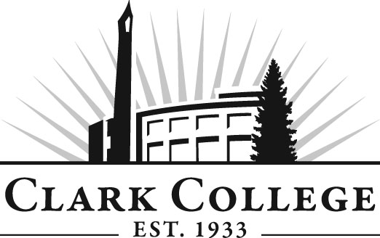

DIESEL TECHNOLOGY ADVISORY COMMITTEE

MINUTES
Wednesday, June 8, 2011
12:00-2:00 PM
PUB258-B

Members Present Representing
Mike Taylor Clark County Skills Center
Bob Mohagen Clyde West Company
Max Smith, Committee Chair Cummins Northwest, LLC
Fred Suckow DSU Peterbilt
Tim Shellenberger, Vice Chair C-TRAN
Lowell McMurray Pacific Power Products, Inc.

Members Absent
Phil Baus Clark County Skills Center
Eric Freimuth Hydraulic Training Associates
Pat Thomas McCoy Freightliner

Clark College
Don Gonser Department Head/Diesel Professor
Dennis Lloyd Diesel Professor
Bill Trousdale Instructional Tech
Chuck Smithfield Instructional Tech
Dedra Daehn Director of Instructional Planning

Mr. Max Smith, committee chair, called the meeting to order at 12:15 with introductions.

Agenda:
Professor Gonser said Mr. Tim Shellenberger will be teaching HVAC class. Over 20 students have requested this class. It will be taught in fall quarter on Monday nights. Mr. Shellenberger said he will also cover ventilation systems.

Professor Gonser also added enrollment and employment opportunity agenda items.

Review of the Minutes of the Previous Meeting:
A motion was made to approve the minutes. The motion was seconded and unanimously approved.

Emissions in the Curriculum:
Mr. Shellenberger and Professor Lloyd said they both teach this subject in their classes.

Enrollment:
Professor Gonser said he has 18 in the spring quarter. Professor Lloyd had 29 in the fall, 31 in the winter and 30 in spring class. First year for Fall 2011 at 26 already.

Employment Opportunities:
Professor Gonser wanted to see what the prospect of student employment was like currently.

Mr. McMurray said they are busy right now and there are some job postings at Pacific Power Products.

Mr. Smith said Cummins has two openings right now, and he said it’s been very busy at the Service Center.

Mr. Suckow said Peterbilt has a couple of entry level openings for Saturday and swing shifts. He said they also need trained people.

Mr. Mohagen said there is nothing available right now at Clyde West but perhaps in the fall could begin hiring.

Budget:
At the Leadership Meeting their Dean informed the group that the entire unit would have $30,000 in equipment budget, which is only a fraction of what they normally have. Professor Gonser distributed a rider to the original budget request and Professor Lloyd requested several lap tops but was funded for one, so plans to request two more. Line item 3, high lift dolly – this is a safety item and it is Professor Gonser’s priority item. This list will be prioritized for the fall Foundation requests.

Diesel Dogs Updates by Dennis Lloyd:
Professor Lloyd said he was pleased letting the students of the Diesel Dogs Club do their fund raising and also finishing up the Mini-Mac.

Work Plan:
Facilities & Equipment: Professor Lloyd talked about asking Facilities Services to remodel Diesel Work area to allow for more storage. He said the space they have right now for storage area can be utilized much better if Facilities will look at the area and come up with more efficient space use.

Mr. Shellenberger said he would like service reports-maintenance management software for writing work orders, etc. He asked if any of the companies might want to donate the program to Clark Diesel Program.

Dedra and Professor Gonser will finalize the draft of the Work Plan and bring it back to the Fall committee meeting for advisory approval.

Advisory Committee Business:
Dedra said the advisory website log-in will be removed but the member lists will still be secured.

Next Meeting:
Wednesdays work best for everybody present. Next meeting mid-late quarter – fall – decided on Wednesday, November 16, 2011.

Meeting adjourned at 1:25 PM.

