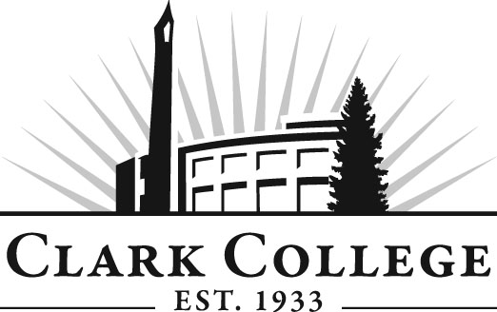

DIESEL TECHNOLOGY ADVISORY COMMITTEE

MINUTES
Wednesday, January 23, 2013
12:00-2:00 PM
JSH, Room 250

Members Present Representing
Max Smith, Committee Chair Cummins NW
Tim Shellenberger, Vice Chair C-Tran
Mike Taylor Cummins Northwest
Eric Freimuth Hydraulic Training Associates
Bob Mohagen Clyde West Company
Fred Suckow DSU Peterbuilt
Jerry Walker jwalker@pac-power.com

Members Absent
Phil Baus Clark County Skills Center
Lowell McMurray Pacific Power Products
Pat Thomas McCoy Freightliner

Clark College
Don Gonser Department Head/Professor, Diesel Tech
Dennis Lloyd Professor, Diesel Tech
Bill Trousdale Instructional Tech
Genevieve Howard Dean, Workforce, Career & Tech Ed.
Dedra Daehn Director Academic Services
Judy Schilz Secretary Senior
John Maduta Advising Divisional Manager - Prof Tech
Programs
Sarah Weinberger Career Services
Andreana DiGiorgio Secretary Sr. Advisory Committees

Meeting was called to order at 12:08 by Max Smith, Committee Chair, with introductions.

Review of the Minutes of the Previous Meeting:
After reviewing the minutes, a motion was made to approve the minutes. The motion was seconded and the minutes were unanimously approved.
Office of Instruction/Advisory Committee Business:
Dedra Daehn reported that the advisory committee agenda format has been changed. The main format change reflects a time column, which places an amount of time to be used for each agenda item with the majority of the meeting focused on the committee’s work plan. Clark College acknowledges and appreciates the time the industry members take out of their schedules and the change in the agenda format is one way to more effectively use the members’ time.

All of the committee rosters are updated at each meeting to help us ensure that the employer/employee ratio is 50% for each group. The State of Washington requires that this information is tracked. The state defines an employer as someone with hiring and firing power.

Ms. Daehn also spoke briefly about Perkins funding. Last spring the college was awarded $575,808 in Perkins funding. It is federal finding that comes through the state and supports Clark’s career and technical programs. The primary focus of using these funds is to prepare students for the workplace, help them improve their technical skills as well as their academic skills.

Another source of funding available to Clark College is the Worker Retraining funds received from the state. The amount of money awarded for 2012-13 was over $1,000,000. This funding is used to support and provide education, training, and career services for dislocated and unemployed workers. Students coming in to Clark who have been laid off or dislocated may be eligible for financial aid and other monetary support because of the Worker Retraining program. These moneys can also support some of Clark’s adjunct faculty and equipment needs.

Dean of Workforce & Career Tech Education Genevieve Howard presented information to the committee on the college-wide Vision 2020 plan. She said that Vision 2020 is a proactive way that the college is getting ready for the future. Ms. Howard asked the committee to start thinking about what the Diesel program should look like in the year 2020. This will include new equipment, if necessary, update curriculum, etc. This will be a new ongoing item to be put on the work plan.

Division Chair Report:
Diesel Program Director Don Gonser reported that enrollment is robust. The program is just shy of 50 students and second year student enrollment is at 30 students.

Work Plan:
The committee agreed to establish a subcommittee to review remodeling options for the Diesel instructional area. It was noted that the classrooms need to be “smart rooms.” The committee agreed to take a look at the proposal, when completed, and provide input.

An equipment plan discussion took place. It was decided that the current equipment list should be reviewed. This will be an added item put on the work plan.

Lastly, the committee discussed software needs. It was agreed that software management programs need to be investigated. This software will provide students learning opportunities to do work orders, among other things. One member offered that CW3 software can be found for free. Don agreed to research this.

Foundation Request:

Also, a motion was made to support a Foundation Grant request for $16,500 for an oil recycling unit ($16,500). The motion was seconded and unanimously carried.

Next Meeting Date:
May 15 or 22, 2013 at noon. An email will be sent later to determine availability of the dates.

The meeting was adjourned at 1:15 p.m.

Prepared and Submitted by Andreana DiGiorgio

