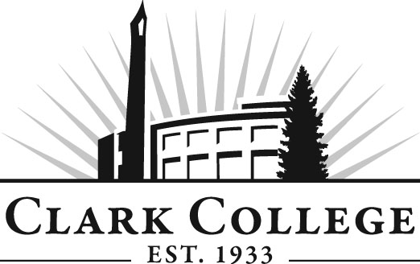

Diesel Tech Advisory Committee

Meeting Agenda
Date: Wednesday, March 14, 2012
Time: 12:00-2:00 PM
Meeting Room Location: PUB-258C

- Call to order- - - - - - - - - - - - - - - - - - - - - - -Mr. Max Smith, Committee Chair

- Welcome & Introduction

- Approval of minutes from last meeting

- Open issues

- Advisory Committee Business- - - - - - Dedra Daehn, Office of Instruction

- Work Plan- - - - - - - - - - - - - - - - - - - - Dedra Daehn, Office of Instruction

- New business

- Budget Cuts

- Internships

- Next Meeting Schedule

