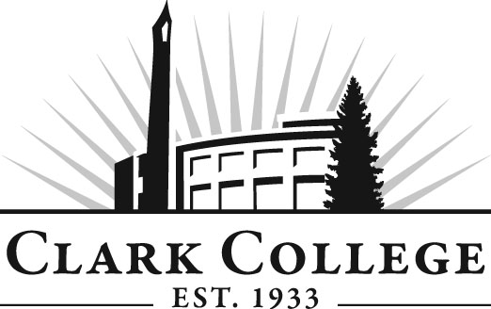

Diesel Tech Advisory Committee

Meeting Agenda
Date: Wednesday, November 16, 2011
Time: 12:00-2:00 PM
Meeting Room: PUB258C

- Call to order- - - - - - - - - - - - - - - - - - - - - - -Mr. Max Smith, Committee Chair

- Welcome & Introduction

- Approval of agenda and minutes from last meeting

- Open issues

- Advisory Committee Business- - - - - - Dedra Daehn, Office of Instruction

- Work Plan- - - - - - - - - - - - - - - - - - - - Dedra Daehn, Office of Instruction

- New business

- Enrollment

- Foundation Requests
- Instructional Technicians
- State Budget Cuts

- Diesel Dogs-ASCC student club activities

- Next Meeting Schedule

