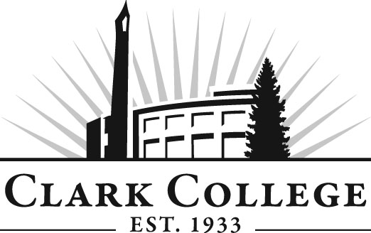

DIESEL TECHNOLOGY ADVISORY COMMITTEE
MINUTES
Thursday, November 13, 2015
12:00-2:00 PM
Joan Stout Hall, Room 250

Members Present: Max Smith, Committee Chair, Cummins Northwest; Bob Mohagen, Clyde West Company; Fred Suckow, DSU Peterbuilt; Gary Dawson, Pacific Truck Products; James Albright, Fedex; Brian Dilitto, Fedex

Members Absent: Mike Taylor, Vice Chair, Cummins Northwest

Clark College: Don Gonser, Department Head/Professor, Diesel Tech; Tim Shellenberger, Adjunct/C-Tran; John Maduta, Advising Divisional Manager - Prof Tech Programs; Andreana DiGiorgio, Secretary Sr., Advisory Committees

The meeting was called to order at 12:09 p.m. by Committee Chair Max Smith and introductions were made.

After reviewing the April 30, 2014 meeting minutes, a motion was made to approve the minutes as presented. The motion was seconded and the minutes were unanimously approved.

Office of Instruction/Advisory Committee Business
Andreana showed the members the advisory website and explained that Clark College has a new web content management system. The new web address is http://clark.edu/advisory/. She referred them to the committee member handbook which has been updated. Next, the committee membership was discussed. She asked that if a member has someone in mind to serve on the committee to send her their contact information and she will start the new member process. Members can also invite a potential new member to any of the meetings. Just let her know whoShe reminded them that anyone can nominate a new member.

Don Gonser spoke about Credit for Prior Learning. He said that Clark has put a new process together for giving credit to veterans and others for prior experience. A key part of this process is that this credit will go on the students’ transcripts as a pass/no pass.

Division Chair Report
Diesel Program Director Don Gonser reported that the caps are at 20 students in the lab. Lecture is 30 and generally higher. He reported that the program is over capacity. Dennis Lloyd’s course is at 29. Don’s is at 24. He said they have another set of eyes on the floor in the instructional techs. They have the capability of providing instruction or subbing. So, all in all they have a very robust enrollment.

Don mentioned that Centralia Community College offers a baccalaureate degree for their Diesel program. They probably would like Clark’s two-year students.

Work Plan
The committee went through the work plan. Updates would be made by Andreana and available on the Diesel Tech Advisory Website. Some of the highlights follow:

Tim Shellenberger and Don will continue investigating new software management programs that cover work orders and other tasks. Gary Dawson said that parts managers can also be a career coming out of the Diesel programs. He would like to see graduates who can read, write, and do math computations. John Maduta told the committee about new applied math and English courses created over last summer to be specially tailored for the technical education programs. Brian Dilitto added new employees are weak on electrical, air brakes, transmissions, etc. He said maybe the two-year diesel students need more time on brakes, electrical, and other basic diesel skills. Much discussion took place about student/employee education with an emphasis on reading and comprehension, and computer skills.

After some discussion about students and employability, Don asked the committee members if they would come in and talk to the students about the job market; how to get jobs, how to keep jobs, how to be employable. Tim Sh. Said a former student Aaron at Pacific could come talk to students and talk about his success. The committee talked about and planned to have an Employability presentation on February 19, 2015 at 10 a.m.—12:00 p.m. and again from 1:00 p.m.—3:00 p.m. Tim, Max, Gary & Brian will work on this.

Don said that Genevieve may have secured funding for needed covered storage space. Equipment can’t be left outside in the rain. Genevieve and Don are planning to go look at PCC’s storage facility for their Diesel Tech program, including their mezzanine, look at their 5-credit interview class, and their work habit safety course.

New Business
Members would like to see students have practice in mock interviews. Can talk about work habits, resume writing, etc. This will be an agenda item for the spring meeting.

Max thought maybe he and Don could attend one of PCC’s Diesel Tech advisory meetings. Max and Don will both make phone calls to their contacts at PCC.

John Maduta will bring a feasibility study to the next meeting.

Next Meeting Date
The committee agreed that the next meeting will be Wednesday, March 26, 2015 at noon.

The meeting was adjourned at 2:59 p.m.

Prepared and Submitted by Andreana DiGiorgio

