Clark College

1933 Fort Vancouver Way
Vancouver, Washington 98663
Highest Ranked Occupations Report

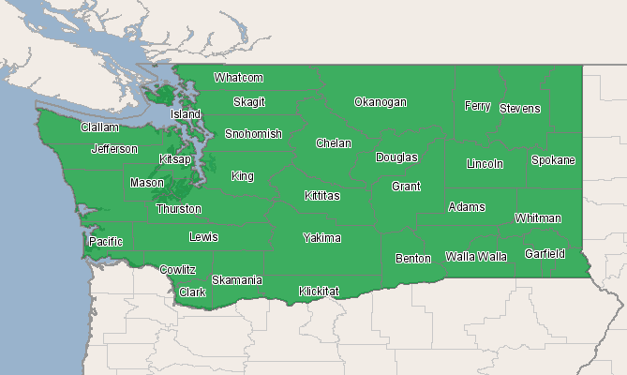
Economic Modeling Specialists, Inc. www.economicmodeling.com


Region Info

Region: WA State
Description: All counties in state of WA
State Area: Washington
Largest Occupations

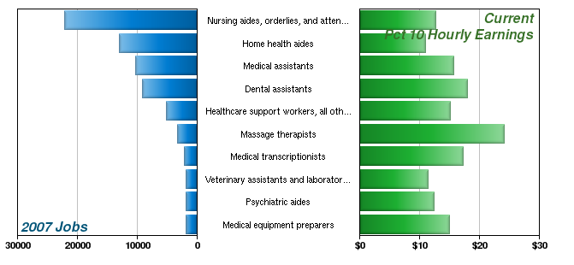
SOC Code | Description | 2007 Jobs | 2012 Jobs | Change | % Change | Current Pct 10 Hourly Earnings
31-1012 | Nursing aides, orderlies, and attendants | 22,206 | 23,850 | 1,644 | 7% | $12.78
31-1011 | Home health aides | 12,933 | 16,217 | 3,284 | 25% | $10.98
31-9092 | Medical assistants | 10,302 | 12,337 | 2,035 | 20% | $15.65
31-9091 | Dental assistants | 9,206 | 10,602 | 1,396 | 15% | $18.04
31-9099 | Healthcare support workers, all other | 5,133 | 5,908 | 775 | 15% | $15.14
31-9011 | Massage therapists | 3,249 | 3,912 | 663 | 20% | $24.19
31-9094 | Medical transcriptionists | 2,092 | 2,293 | 201 | 10% | $17.24
31-9096 | Veterinary assistants and laboratory animal caretakers | 1,917 | 2,121 | 204 | 11% | $11.39
31-1013 | Psychiatric aides | 1,863 | 2,108 | 245 | 13% | $12.37
31-9093 | Medical equipment preparers | 1,809 | 1,988 | 179 | 10% | $15.07
Source: EMSI Complete Employment - 2nd Quarter 2010

Highest Paying Occupations

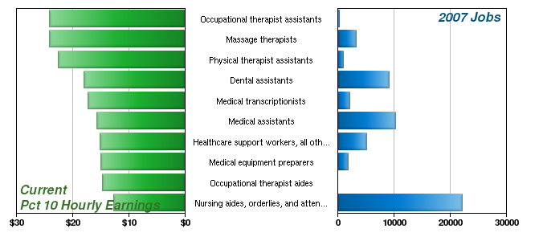
SOC Code | Description | 2007 Jobs | 2012 Jobs | Change | % Change | Current Pct 10 Hourly Earnings
31-2011 | Occupational therapist assistants | 274 | 317 | 43 | 16% | $24.20
31-9011 | Massage therapists | 3,249 | 3,912 | 663 | 20% | $24.19
31-2021 | Physical therapist assistants | 989 | 1,164 | 175 | 18% | $22.56
31-9091 | Dental assistants | 9,206 | 10,602 | 1,396 | 15% | $18.04
31-9094 | Medical transcriptionists | 2,092 | 2,293 | 201 | 10% | $17.24
31-9092 | Medical assistants | 10,302 | 12,337 | 2,035 | 20% | $15.65
31-9099 | Healthcare support workers, all other | 5,133 | 5,908 | 775 | 15% | $15.14
31-9093 | Medical equipment preparers | 1,809 | 1,988 | 179 | 10% | $15.07
31-2012 | Occupational therapist aides | 49 | 57 | 8 | 16% | $14.74
31-1012 | Nursing aides, orderlies, and attendants | 22,206 | 23,850 | 1,644 | 7% | $12.78
Source: EMSI Complete Employment - 2nd Quarter 2010
*Note: Occupations with fewer than 10 employees are not shown.

Fastest Growing Occupations

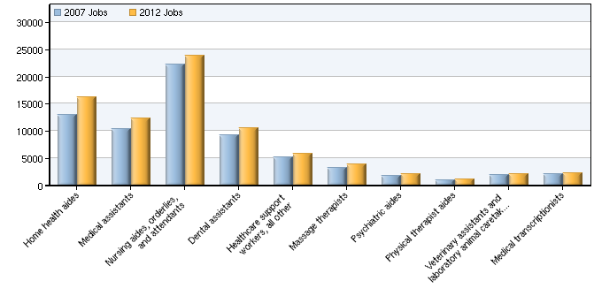
SOC Code | Description | 2007 Jobs | 2012 Jobs | Growth | Growth % | Current Pct 10 Hourly Earnings
31-1011 | Home health aides | 12,933 | 16,217 | 3,284 | 25% | $10.98
31-9092 | Medical assistants | 10,302 | 12,337 | 2,035 | 20% | $15.65
31-1012 | Nursing aides, orderlies, and attendants | 22,206 | 23,850 | 1,644 | 7% | $12.78
31-9091 | Dental assistants | 9,206 | 10,602 | 1,396 | 15% | $18.04
31-9099 | Healthcare support workers, all other | 5,133 | 5,908 | 775 | 15% | $15.14
31-9011 | Massage therapists | 3,249 | 3,912 | 663 | 20% | $24.19
31-1013 | Psychiatric aides | 1,863 | 2,108 | 245 | 13% | $12.37
31-2022 | Physical therapist aides | 996 | 1,210 | 214 | 21% | $12.07
31-9096 | Veterinary assistants and laboratory animal caretakers | 1,917 | 2,121 | 204 | 11% | $11.39
31-9094 | Medical transcriptionists | 2,092 | 2,293 | 201 | 10% | $17.24
Source: EMSI Complete Employment - 2nd Quarter 2010

Data Sources and Calculations

Occupation Data

Organizing regional employment information by occupation provides a workforce-oriented view of the regional economy. EMSI's occupation data are based on EMSI's industry data and regional staffing patterns taken from the Occupational Employment Statistics program (U.S. Bureau of Labor Statistics). Wage information is partially derived from the American Community Survey. The occupation-to-program (SOC-to-CIP) crosswalk is based on one from the U.S. Department of Education, with customizations by EMSI.
State Data Sources

This report uses state data from the following agencies: Washington State Employment Security Department, Labor Market and Economic Analysis Branch.

