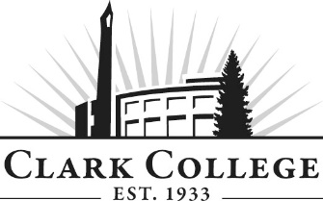
CULINARY ARTS ADVISORY COMMITTEE - MINUTES
Tuesday, May 26th, 2020 2:30 – 4:30 p.m.
Zoom Online

Members Present: Dave Angell, Ft. Vancouver HS; Rebecca Angell, Ft. Vancouver HS; David Finnie, Ft. Vancouver HS; Paul Lemke, Quarry Senior Living; Daniel Miles, MarkeTeam; Warren Neth, Community Member

Members Absent: Ron Onslow (Committee Chair) Mayor of Ridgefield & Retired Restaurateur; George Akau, Retired Instructor; Russell Brent, Mill Creek Pub Owner; Tom Cook, Pacific Bells; George Langevin, Providence Portland;); Andrew Otteraaen (Committee Vice Chair), VA; Tom Wright, Tommy’s Catering

Clark College: Aaron Guerra, Chef – Culinary Arts; Robert (Earl) Frederick, Chef; Shannon Jackson, Advising; Armetta Burney, Interim Dean – Workforce/PTE; SueAnn McWatters, Program Specialist – Advisory Committees

SueAnn McWatters opened the meeting at 2:36pm and introductions were made.

  - MINUTES OF THE PREVIOUS MEETING

The minutes of November 5th, 2019 of the previous meeting were presented for approval; as quorum was not present, the minutes were sent out via electronic approval.

As of June 24th, 2020 the minutes were approved.

  - NEW MEETING DATE

The next meeting will be Tuesday, December 1st, 2020 at 2:30pm.

Due to many changes, the meeting was rescheduled to Tuesday, March 9th, 2021 at 3:00pm.

  - COVID-19 STATUS AND CHANGES

Industry

Instruction

  - COLLEGE GOALS AND PLANS

  - FOOD FOR THE COMMUNITY

  - OPEN FLOOR DICUSSIONS

Meeting adjourned at 3.58pm.

Prepared by SueAnn McWatters

