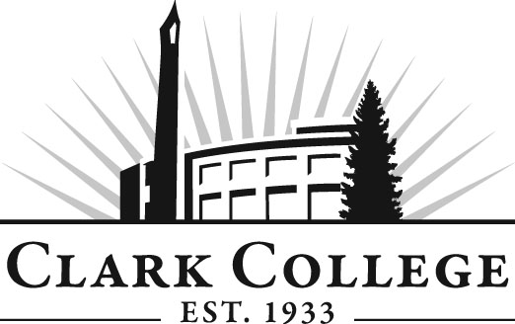

BUSINESS TECHNOLOGY ADVISORY COMMITTEE

MINUTES
Tuesday, February 26, 2013
4:00—6:00 PM
Scarpelli Hall 216

Members Present Representing
Leslie Hinton, Committee Chair Clark County Skills Center
Dee Clinton Hewlett Packard
John LeMarte WorkSource Vancouver
Donna Martin Bonneville Power Admin.
Shari Jensen Clark County

Members Absent
David Keeler, Vice Chair Kelly Services
Sanjay Vankudre IEM Solutions
Tami McEldowney Office Team
Carri MacPherson Bonneville Power Admin.

Clark College
Mary Evens Division Chair/Professor, BTEC
Marilyn Hale Professor, BTEC
Helen Martin Professor, BTEC
Betty Barrows BTEC Instructor
Dedra Daehn Director of Academics
Kathy Ostermiller Secretary Sr., Tenure
John Maduta Advising Divisional Manager
Sarah Weinberger Career Services
Andreana DiGiorgio Secretary Sr., Advisory Committees

The meeting was called to order at 4:02 pm and introductions were made.

Review and Approval of Minutes from the Previous Meeting
The committee agreed to approve the minutes via email as there was not a quorum present.

Office of Instruction Updates
Director of Academic Services, Dedra Daehn, shared that the college is implementing a new program improvement process. It is a process that will schedule each program to undergo a review. The data comes from the Virtual Notebook, which is an in-house database of program information such as enrollment, completions, and success rates. It is an opportunity for the faculty and advisory committee to engage in feedback to Clark College. This information will go to the Planning & Effectiveness office to ask questions about the data and see if any adjustments need to be made to the program(s). The whole purpose is to support continuous quality improvement in Clark’s programs.

Ms. Daehn also let the committee know that Job & Occupation Reports are posted on the BTEC website. This data is pulled from the Economic Modeling Specialists International database, which includes national labor and market information. The data on the website includes both Multnomah and Clark counties.

Ms. Daehn reminded the committee of Clark’s Vision 2020 program. She urged the committee to keep the discussion ongoing regarding funding and program changes that may be necessary for keeping the BTEC programs current though the year 2020. This will be put on the work plan and a discussion will take place at each advisory meeting. She suggested to the committee that they could take the data from the Job & Occupation reports and tie it into the Vision 2020 discussion. This could be an agenda item for the next advisory meetings.

Work Plan
The following items were kept on the 2012-13 Business Technology Work Plan:

- Provide input on the implementation of program and course outcomes as well as assessments.
- Research potential colleges and universities, within the local region, that may be interested in formulating an articulation agreement with Clark College for selected BTEC programs. Marylhurst and WSU-V will be the first to be investigated.
- Review Virtual Notebook data to examine current and future instructional staffing and other programmatic needs of the BTEC unit.
- Provide input into the 3-5 year equipment plan for the BTEC unit.

Director/Division Chair Report:
BTEC Instructor Marilyn Hale reported for Division Chair Mary Evens. Faculty recently went through the program outcomes and worked out what the assessments should be. One item discussed was that there are two Microsoft WORD programs, one 3 credit and one 5 credit class which need to be evaluated. The 3 credit class covers the same amount of information as the 5 credit class. The other item flagged was the BTEC Seminar, which is the companion class to the Co-op Work Experience. This course focuses on soft skills and human relations. A discussion took place on how to assess the soft skills of the students. Leslie Hinton mentioned that the new term is 20th Century Skills. Ms. Hale asked the committee to give feedback if they have any ideas how to assess soft skills. Ms. Hale brought up the outcomes for the committee to look at and discuss. Ms. Hinton mentioned that the outcomes could be either emailed or posted to the BTEC website for the committee to look at and bring feedback to the next meeting. She also asked that class titles be listed with the class numbers so that the committee knows what the classes are.

Sharepoint and Outlook. Ms. Hale reported that Mary Evens wanted the committee to give feedback whether these two programs should be taught in the BTEC programs. One member mentioned that Outlook should be taught since many companies utilize the program.

Microsoft Office 2010 & 2013. Ms. Hale reported that there were no plans yet to upgrade to version 2013. John LeMarte explained that there is not a lot of differences in the programs other than some added advanced features. However, the basic program remains the same.

New Business
Division Chair Mary Evens joined the meeting late. She told the committee that there was a new tenure track position open and closed the previous Monday. By mid-April all interviews should be complete. The top 3 will be interviewed and chosen by the VP of Instruction and the President.

Next Meeting Date
After some discussion of the next meeting date, Dedra suggested that Andreana could send out a couple of dates to see which one will work best for the committee members.

The meeting was adjourned at 5:25 p.m.

Prepared/Submitted by Andreana DiGiorgio

