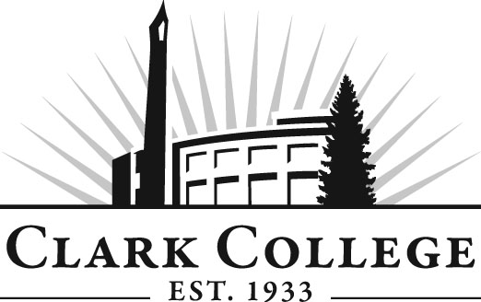

MEDICAL OFFICE TECHNOLOGY
ADVISORY COMMITTEE

MINUTES
Monday, April 23, 2012
6:00 PM ~ 8:00 PM
Scarpelli Hall Room 103

Members Present Representing
Leslie Hinton Clark County Skills Center
Clay Foster, MHA Rebound Orthopedics
Dr. Keith Klatt Urgent Care Northwest
Carol Courtney, Committee Chair Consultant
Diana Morris, RHIA The Vancouver Clinic
Barbara Persinger, Vice Chair PeaceHealth Southwest Medical Center
Lynda Steltz, RHIT, CHP Vibra Specialty Hospital
Katie Woods The Vancouver Clinic
Dee Oglesbee, CMA Urgent Care NW
Sarah Emerson, CMA The Vancouver Clinic

Members Absent
Diana Rogers, RHIT PeaceHealth SW Medical Center

Clark College
John Clausen, RHIA Department Head, Professor
Barbara Benge, CMA Instructor
Sunnie Elhart-Johnson Instructor
Frances Bard Student in the Program
Genevieve Howard Dean, Workforce, Career & Technical
Education
Dedra Daehn Director, Academic Services
John Maduta Advising
Mark Gaither CCE

The meeting was called to order at 6:05 PM by Ms. Carol Courtney, Committee Chair with introductions.

Review of the Minutes of the Previous Meeting:
A motion was made to approve the minutes as written. The motion was seconded and unanimously approved.

Advisory Business:
Ms. Dedra Daehn reviewed the Work Plan to update any new projects and moving completed items off the plan. Ms. Daehn announced that she will update the draft as discussed today and send the draft on to Professor Clausen for his approval and have it ready for discussion at the fall meeting.

Professor Clausen talked a little about the capstone class. He said Professor Elhart will talk about what she is planning later with the enhanced coding classes to match the Shoreline College.

Professor Clausen also said the separate units are developing their equipment plan and many of the committees put that on the Work Plan. He also said the Business Medical Office Technology Program and curricula could be added to the Work Plan. Professor Clausen distributed the details to the Business-Medical Office Technology program and asked the members to review this handout at their leisure. He also said Medical Transcription is no longer offered in the program.

Limited Entry and Sequencing of Courses:
Dean Howard talked about how having limited entry and sequencing of courses would allow the college to see how many students are in the program at any given time.

Health Informatics Capstone Class:
Professor Elhart said that this was being offered as a somewhat of an experimental 280 class. Professor Clausen said that he will be sending students to the directive practices class.

Plans for Redacted Medical Records:
Professor Clausen said that 24 BMED students will go through Redacting project at PeaceHealth. Mark Gaither showed the electronic health records the students would be working with.

Health Informatics Articulation with Shoreline Community College:
Professor Clausen said the health informatics program offered at Shoreline is all on-line so the students do not have to travel to Shoreline from Clark College. Clark has a guarantee of five student slots from Shoreline. Professor Clausen said that employment opportunities were also available in the Shoreline district.

Professor Clausen suggested anyone interested in the Southwest Washington Regional Health Alliance talk to Mark Gaither to get more information.

He also said many of the hospitals and clinics are merging together and many of the electronic records allow patients to check their own charts.

Work Plan:
Ms. Carol Courtney said at the last meeting she and the committee had no clue what was necessary for the work plan nor what the purpose was for the work plan. Dean Howard took a few minutes to explain the purpose of the work plan.
Next Meeting:
Monday, June 11, 2012. For the agenda, curriculum items will be discussed as well as limited entry and enhancing the courses.

The meeting adjourned at 7:00 PM.

