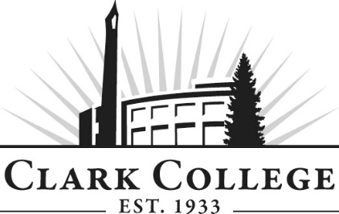

**ADDICTION COUNSELING ADVISORY COMMITTEE**

**MINUTES**

**Friday, March 4th, 2022 * 11.30am-1.00pm**

**Zoom Online**

**Members Present** Lynette Tracy (Committee Chair), Lifeline Connections; Rebecca Bradley, Rainier Springs; Laurie Ellett, Helping Professionals Wellness Center; Denise Hurley, Cowlitz; Sean Moore, Workforce SW; Lindsay Newcomer, Family Promise of Clark County; Britney Sorensen;

**Members Absent**: Ken Burton (Vice Chair), Lifestance Health; Mariele Balasbas, Boys and Girls Club; David Cole, Family Promise of Clark County; Vince Collins, Recovery Café; Aaron J. Larson, American Behavioral Health Systems; Sebastian Molfa, Columbia River Mental Health Services; Katie Moore, Daybreak Youth Services; Scott Sims;

**Clark College**: Marcia Roi, Department Head; Chris Thompson, Clark County/Instructor/Advisor; Jim Jensen, Instructor; Don Ludwig, Department Chair/Professor; Joe Jenkins, Advising; SueAnn McWatters, Program Specialist – Advisory Committees

Lynette Tracy called the meeting to order at 11:32am and introductions were made.

**APPROVAL OF PREVIOUS MEETING MINUTES**

*The minutes of November 5th, 2021 will be sent out for electronic approval.*

**NEXT MEETING DATE**

The committee will meet again **Friday, March 4th, 2022 at 11:30am.**

**ANNOUNCEMENTS FROM THE COLLEGE**

SueAnn McWatters made the following announcements:

**ACED/BASHS PROGRAM UPDATE**

**SUDP SUPERVISORY COURSE**

**PEER CERTIFICATE**

**INDUSTRY UPDATES**

Lynette Tracy adjourned the meeting at 1:11pm.

Prepared by SueAnn McWatters