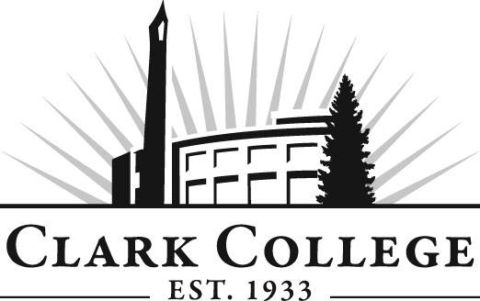
Addiction Counselor Education Advisory Committee
Meeting Agenda
Friday 21st October 2016: 11.30am-1.30pm
Hanna Hall, room 109

Agenda Item | Expected Outcome
- Call Meeting to Order – Committee Chair | N/A
- Welcome and Introductions – Committee Chair | New members/guests introduced
- Approval of Minutes from Last Meeting – Chair | Corrections indicated and/or approval of minutes as written.
- Office of Instruction Updates – Cathy Sherick

- Director/Division chair Report
- Marcia is in Ellensburg as president of WACASE

- Work Plan-Committee Chair and Program Director/Division Chair | Implement strategies as outlined in work plan. If necessary, identify work groups.
- Old Business-Follow-up- Committee Chair

- New Business  - BAS exploration- Miles Jackson  - Introduction of new member | Input from providers as to demand for BA students
- Summary of follow-up action items – Committee Chair | Summary of follow-up actions communicated to the committee.
- Establish next meeting date and adjournment – Committee Chair | Meeting date established.

