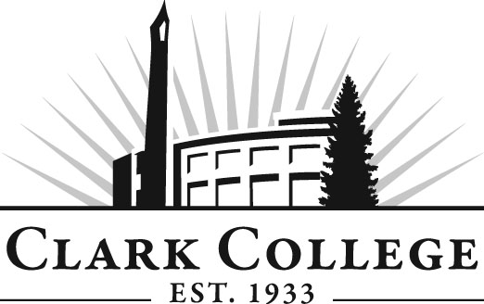

ADDICTION COUNSELING ADVISORY COMMITTEE
MINUTES
Friday, January 29th 2016
11.30am-1.30pm
HHL 117

Members Present: Lynette Tracy (Committee Chair) Lifeline Connections, Sandi Kendrick, Vice Chair, Clark County Public Health; Chris Thompson, Clark County; Justene Dillard, Helping Professionals; Ed Febish, Columbia River Mental Health; Phillip Muir, Western Psychological Services, Chris Standridge

Members Absent: Jared Sanford, Lifeline Connections; Sybil Iverson/Helen MacArthur, Cowlitz Tribal Treatment

Clark College: Dr. Marcia Roi, Professor, Addiction Counseling Ed.; Catherine Kroll, Professor; Miles Jackson, Dean, Social Science & Fine Arts; Eliot Altshul, Clark College counseling Center

_________________________________________________________________________________________________

Lynette Tracy called the meeting to order

The minutes from the meeting on September 25, 2015 were voted: the vote to approve the minutes as written was unanimous

Department Updates

Marcia Roi reported that the ACED program is to be retained, however it will be scaled down. Marcia will conduct the advising next year and the administration is requesting cutting 8 sections from the course offerings.

Marcia and Jim attended the NW Recovery Project in September in an effort to recruit students.

Marcia has turned in the IR&RC curriculum study guide to DSHS. SAMSHA will publish it as a white paper. The Washington Recovery Alliance is working to implement a Recovery Coach credential in the state. The curriculum guide will assist the faculty in curriculum development for the IC&RC exam. The next step is to work with the WRA lobbyist to suggest legislation moving the training to the community colleges. The goal is for Clark College to offer a Recovery Coach Certificate of Proficiency.

The Bellevue BAS is currently on hold until further notice. The administrator who was overseeing the project left the college and a replacement has not yet been hired.

Eliot Altschul from the Clark College counseling center was in attendance at the request of Jim Jensen. Jim was tasked with inviting him for the purpose of partnering with the committee members to offer Chemical dependency assessments to Clark Students who might benefit from referrals to the treatment agencies. Professor Altschul reported that the Counseling center staff assess for substance abuse problems currently. Justene asked which instruments they utilize. He stated they do not use any of the industry-standard instruments for their assessments. He explained that none of the current staff have any background in addictions treatment but he felt they were qualified to conduct assessments. Justene asked how many referrals have been made as a result of their assessments. He stated there has never been a referral that he is aware of as a result of the assessments, as it was not necessary. Professor Altschul stated that the Counseling center would not be made available for any assessments from any of the committee member agencies as the counselors were not available after hours, nor would there be room during the workday.

Marcia introduced the tentative articulation agreement she was working with City University. Discussion ensued as to the cost and duration. Also how much of the degree was online. Ratification was tabled until the total cost was determined as well as the placement rate, completion rate and the average student debt was determined. A motion was made to table the agreement until these items were brought to the next committee meeting.

Jim had information regarding recovery schools but the time ran out and it was agreed to move this topic to the next meeting.

Next Meeting Date

The next meeting was scheduled for April 22, 2016.

The meeting was adjourned.
Prepared/submitted by Marcia Roi

