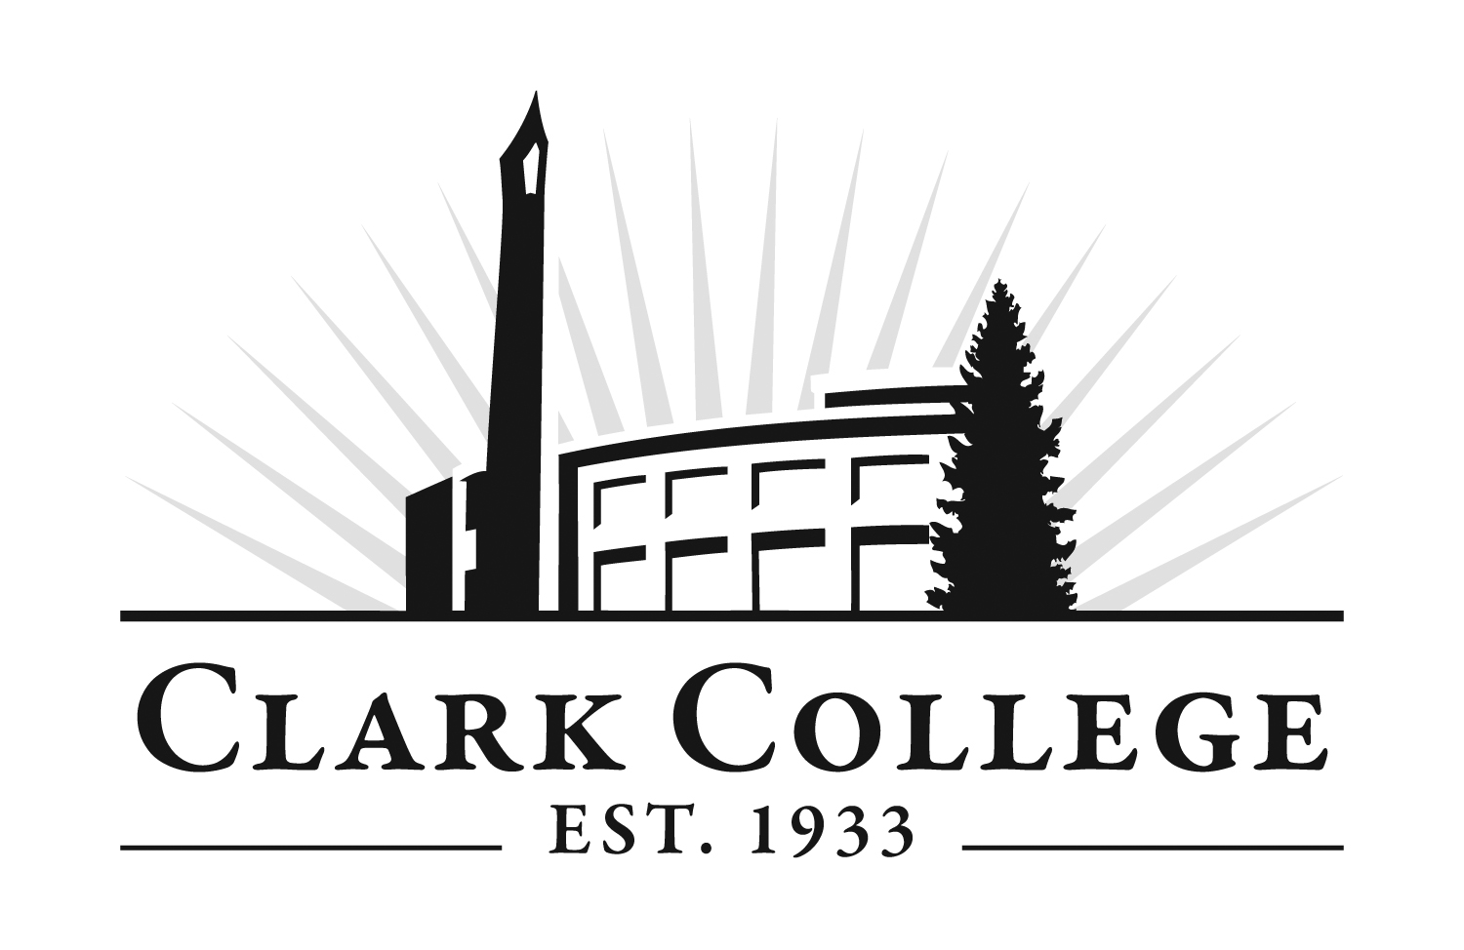
Phlebotomy Program Application

*Name: ___________________________________________________ *Student ID# ________________________
Phone# _____________________________ *Email: ____________________________________________________
Select desired entry term: Winter____ Spring____
Please include transfer credit from the following institution/s: ______________________________________

Please email completed applications to enroll@clark.edu. To mail applications, please send to:
Clark College-Enrollment Services, 1933 Fort Vancouver Way, Vancouver, WA 98663.

To be eligible for selection into the Phlebotomy program, the following items must be completed:
Complete the Clark College Application for Admission, if needed. The Clark College application fee is $30 and applies to all new and returning students. We encourage all students to visit Enrollment Services or the One Stop on Clark College’s Main Campus with valid photo ID or high school ID to receive a code to apply for free. For more information, visit: https://www.clark.edu/getstarted/
Complete this Phlebotomy CA program application. Read and initial each item on page 2., ensuring to complete the high school attestation questions. Your application affords you two selection attempts.
Pay the non-refundable $50 program application fee. Your application is complete when the fee is paid, and this date is the ‘application received’ date. This date may be considered in the selection process. (Fees are subject to change.)
Submit official transcripts if you have transfer credits you wish to apply to the program. Transfer credit and course equivalencies will be determined by Clark College.
Eligibility for ENGL& 101+99.
Obtain a minimum Clark College applicable GPA of 2.5 or higher. Applicable GPA courses are: AH 100, 104, 110, CMST& 210 and ENGL 90.

The following courses must be completed with a “C”, (2.0) grade or higher prior to entering the program:
Course | Course Name | Credits
AH 100* | Basic Concepts of Human Anatomy & Physiology w/Lab I | 3
AH 104 | Healthcare Delivery & Career Exploration | 3
AH 110* | Medical Terminology I | 3
AH 120** | Bloodborne Pathogens in Healthcare Settings | 1
Not required for selection; must complete by 1st term in program.
HLTH 124** | Healthcare Provider CPR & First Aid (may complete early) | 1
CMST& 210  or  MA 124 | Interpersonal Communication (may complete early)  Therapeutic Communication Skills for Health Professionals (taken after entry) | 5  2
*must be 7-years current upon program entry
**contact Credentials for credit for prior learning (CPL) if you have current certifications: credeval@clark.edu

Please Complete Second Page

PLEASE INITIAL IN THE SPACES PROVIDED TO CONFIRM YOU HAVE READ AND ARE AWARE OF THE FOLLOWING
ADDITIONAL REQUIREMENTS FOR PROGRAM ENTRANCE
Phlebotomy Standard Technical Requirements
*Physical and mental/emotional requirements: ability to work in a fast-paced environment, often on your feet for 8 hours continuously, as well as bending, reaching and pushing carts with equipment for extended periods of time; phlebotomists are typically required to carry and lift up to 30 lbs.; use of hands for fine, repetitive manipulation of small objects; utilize various laboratory equipment and have basic computer proficiency; must possess excellent customer service and communication skills; ability to work with diverse patient populations; ability to maintain professional composure around patients that are sick and/or terminally ill.
*Working conditions: positions in the laboratory and/or clinical settings may require working flexible schedules, including nights, weekends and holidays; potential exposure to blood, body fluids and chemical hazards; ability to wear gloves and other personal protective equipment (mask, coat, etc.) for extended periods of time.
*To participate in this program, students must be able to meet the standard technical requirements as listed above. Admission to the program is contingent upon the applicant verifying his or her ability to perform the established technical standards of the program with or without reasonable accommodation by completion of a medical evaluation (please reference the disability statement in the online Phlebotomy handbook for additional information: www.clark.edu/phlebotomy).
*In Washington state, phlebotomists are required to have a license issued by the State Department of Health (DOH) to gain employment. To obtain a license, students provide proof of completion of the program and pay an application fee to the DOH. Students who complete the program can gain employment in most other states without a license, except for California, Nevada, and Louisiana. Additionally, students who complete the program are eligible to sit for a National Phlebotomy Certification exam to enhance employment opportunities in states with and without licensure requirements.
*The program requires approximately 9 to 40 hours per week (9 the 1st quarter and up to 40 hours/week the 2nd quarter) commitment from students for classes and the clinical experience (not including outside study or travel time to the clinical site). Students will complete 150 hours of non-paid clinical training (approximately 19 days) in the 2nd quarter and may need to budget for loss of income during this time if they typically work full or part-time. Reliable transportation is an important consideration as clinical facilities may require driving significant distances. Clinical assignments may be required at times other than traditional work hours, such as early morning shifts beginning at 3:00 or 4:00 am.
*To participate in the clinical experience course, clinical sites will require proof of current immunizations. Students should start the Hepatitis B series and titer as soon as possible as this can take up to seven months to complete. Evidence of immunization is required before participation in the 2nd quarter clinical course. Please see the program website for details on immunizations requirements. Immunization requirements will be covered during phlebotomy student orientation.
*This program highly recommends all students to be vaccinated against COVID-19 as a requirement for most clinical placements.
*Before enrolling in clinical courses, students must complete a comprehensive Criminal Background Check, as required by the clinical site. Students should be aware that the clinical site may deny the student access and the student may not be able to complete their healthcare program based on the results of background checks.
*All students are required to complete a urine drug screen before beginning their clinical course, as required by the clinical site. Drug screening costs are the responsibility of the student (approximately $50). If the clinical site finds the student’s drug screen to be unsatisfactory, the student may be dismissed from the program (see substance abuse policy in Phlebotomy Handbook).
*Students must provide proof of health insurance before beginning their clinical course. Students are responsible for their own health evaluations and testing requirements should an accident or injury occur at any time during participation in the program.
*Washington State Law [246-827-0410] requires that students have completed high school graduation or GED completion to be eligible for selection into the Phlebotomy program:
>>>REQUIRED ATTESTATION: Have you earned a high school diploma or GED? * YES NO
If yes, please tell us which one you completed: * ____________________________ Date completed: * _________________
*I have reviewed the program requirements on the Clark College website. I am aware of entrance requirements, selection processes, required immunizations, criminal background check requirements, and all other specific program information. I am aware that completion of pre-entrance requirements does not guarantee entrance into the program and understand that additional preparation may be needed for final program selection.
*I understand that any misrepresentations or false statements on this application will be subject to the Clark College and program code of conduct disciplinary procedures.
*___________________________________________ *____________________________________________________ *________________________
Print Name Signature Date
The college affirms a commitment to freedom from discrimination for all members of the college community. The responsibility for, and the protection of, this commitment extends to students, faculty, administration, staff, contractors, and those who develop or participate in college programs. It encompasses every aspect of employment and every student and community activity. The college expressly prohibits discrimination on the basis of race, color, national origin, age, perceived or actual physical or mental disability, pregnancy, genetic information, sex, sexual orientation, gender identity, marital status, creed, religion, honorably discharged veteran or military status, or use of a trained guide dog or service animal. Harassment is a form of discrimination. Alternate format of this document is available upon request. Please contact Disability Support Services at (360) 992-2314 or (360) 991-0901 video phone.

