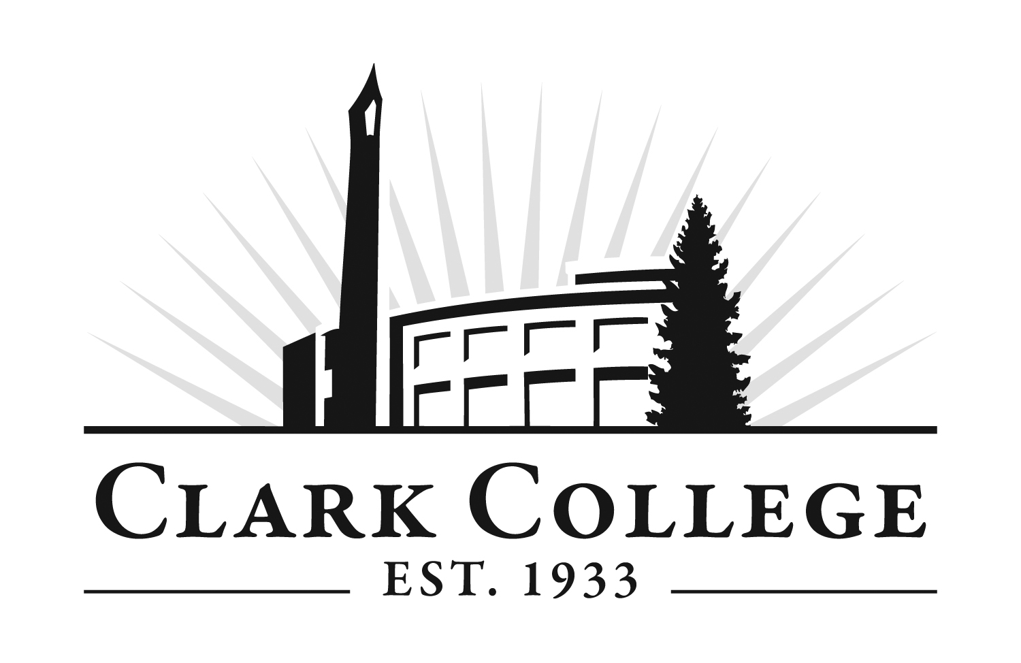
Bachelor of Applied Science
Dental Hygiene
Statement of Intent Form

Name: __________________________________________________________ Student ID# _____________________________
Other Names: ________________________ Phone#_______________ Email: ______________________________________
Please list all colleges attended: | Degree Earned:

To be eligible for selection into the Dental Hygiene program, the following requirements must be completed:
Complete the Clark College Application for Admission, if needed. The Clark College application fee is $30 and applies to all new and returning students. We encourage all students to visit Enrollment Services or the One Stop on Clark College’s Main Campus with valid photo ID or high school ID to receive a code to apply for free. For more information, visit: https://www.clark.edu/getstarted/
Submit this Statement of Intent form by the January 8th application deadline. Read and initial each item on page 2.
Pay the non-refundable $50 program application fee. Your application is complete when the fee is paid.
(Fees are subject to change.) You will receive an emailed request to pay the program fee 4-5 days after your application is received. Please pay online or at the Cashiers office.
Submit official transcripts from all outside colleges attended. Transfer credit and course equivalencies will be determined by Clark College.
Obtain a minimum applicable GPA and science GPA of 2.6 or higher. Obtain a “C”, (2.0) grade or higher in each required preliminary course. See below for additional information. *
No more than 10 credits of preliminary required coursework may be lacking at the time of application for the following fall class. All requirements must be completed by the prior spring term.

Volunteer Hours: If you have accrued community service volunteer hours, submit the “Volunteer Experience” form with this statement of intent. For more information, visit https://www.clark.edu/academics/programs/health-care-and-biosciences/dental/volunteer-experience-form.pdf.
Volunteer Institution: |  |  |  | Hours:
Prior to entering the program, all required preliminary courses must be completed with a “C”, (2.0) grade or higher.
The science courses below, excluding BIOL&160, must have a cumulative GPA of 2.6 or higher. This is the Science GPA requirement. *
Required |  | Credits | List Course Completed/In-Progress |  | College
BIOL& 160 | General Biology w/Lab | 5
BIOL& 241 | Anatomy & Physiology I | 5
BIOL& 242 | Anatomy & Physiology II | 5
BIOL& 260 | Microbiology | 5
CHEM& 121 | Intro to Chemistry: Pre-Health | 5
CHEM& 131 | Intro to Organic/Biochemistry | 5
NUTR& 101 | Nutrition | 5
The courses below, in combination with the above courses, must have a cumulative GPA of 2.6 or higher. This is the Applicable GPA requirement. *
ENGL& 101 | English Composition | 5
ENGL& 102 | English Composition II | 5
PSYC& 100 | General Psychology | 5
SOC& 101 | Intro to Sociology | 5
MATH 100-lvl | College-level mathematics | 5
HUMANITIES | Any humanities course | 5
CMST& 210/220/230/240 | CMST-select one | 5
PE Activity | Any physical activity course | 1

PLEASE INITIAL IN THE SPACES PROVIDED TO CONFIRM YOU HAVE READ AND ARE AWARE OF THE FOLLOWING ADDITIONAL REQUIREMENTS FOR PROGRAM ENTRANCE

College correspondence is conducted via email, so it is important to keep your email address current in your ctcLink account and to check it regularly.
To participate in the program, students must be able to meet the communication, physical and mental requirements necessary to ensure the safe performance of hygienist responsibilities.
Admission to the program may be contingent upon the applicant verifying his or her ability to perform the established technical standards of the program, with or without reasonable accommodation. Please reference the disability statement in the online Dental Hygiene handbook for additional information.
It is strongly recommended that all applicants closely observe the activities of those practicing in the profession to fully understand the technical requirements of the program.
The program requires a 40 hour-per-week commitment from students for classes and clinical rotations. Clinical assignments may be offered at times other than traditional clinical hours, such as evenings and weekends (other than Monday-Friday, 5:00am-7:00pm). Reliable transportation is an important consideration.
Students enrolled in clinical courses are required to complete a comprehensive Criminal Background Check. Students should be aware that certain convictions may prevent clinical placement and employment, and that completion of this program does not guarantee certification, licensing or employment.
I understand that upon acceptance, there is a $300 non-refundable deposit.
Please be aware that applicants who have failed or been dismissed from a limited entry program will not receive admission into the Clark College Dental Hygiene program.
I have reviewed the program requirements on the Clark College website. I am aware of entrance requirements, selection processes, required immunizations, criminal background check requirements, and all other specific program information. I am aware that if selected into the program, clinical sites may require drug screening. I am aware that completion of pre-entrance requirements does not guarantee entrance into the program.
I understand that any misrepresentations or false statements on this application will be subject to the Clark College and program code of conduct disciplinary procedures.

Please email completed applications to enroll@clark.edu. To mail applications, please send to:
Clark College-Enrollment Services, 1933 Fort Vancouver Way, Vancouver, WA 98663.

___________________________________________ ____________________________________________________ ________________________
Print Name Signature Date
The college affirms a commitment to freedom from discrimination for all members of the college community. The responsibility for, and the protection of, this commitment extends to students, faculty, administration, staff, contractors, and those who develop or participate in college programs. It encompasses every aspect of employment and every student and community activity. The college expressly prohibits discrimination on the basis of race, color, national origin, age, perceived or actual physical or mental disability, pregnancy, genetic information, sex, sexual orientation, gender identity, marital status, creed, religion, honorably discharged veteran or military status, or use of a trained guide dog or service animal. Harassment is a form of discrimination. Alternate format of this document is available upon request. Please contact Disability Support Services at (360) 992-2314 or (360) 991-0901 video phone.

