Career and Technical Education (CTE) Dual Credit at Clark College

Program Overview

Career and Technical Education (CTE) Dual Credit, formerly known as Tech Prep, provides career pathways for high school students. CTE Dual Credit classes are taught at the high school or skills center and integrate academics with technical skills to help prepare students for advanced education and careers related to professional-technical occupations. All CTE Dual Credit courses offer high school and college credit for successfully completing the same class.

Process and Timeline for CTE Dual Credit Articulation Approval:

April 26 All continuing articulation requests and all requests for new articulation for
2024-25 are due to Clark College (dualcredit@clark.edu).

April 29 - May 10 Dual Credit staff review new articulation requests for completeness and forward to faculty for review.

May 13 – May 31 New articulation requests are reviewed by faculty, then approved, denied, or returned for revisions.

June 3 – 14 Dual Credit staff create 2024-25 articulation agreements for approved requests.

June 17 - 28 School Districts notified of approved 2024-25 articulations and agreements are signed.

Fall 2024 Teachers sent annual welcome letter with CTE Dual Credit program details.

Clark College CTE Dual Credit Pathways
The goal of Clark College’s CTE Dual Credit program is to provide access to entry-level classes in the following Areas of Study. For more information go to Clark College Areas of Study.

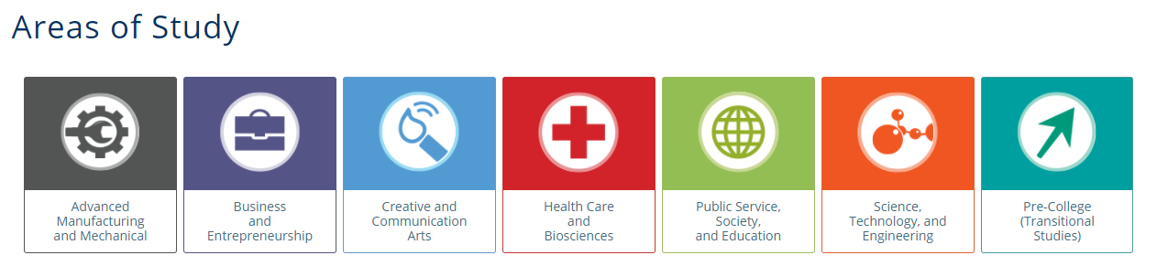

Deadline: All articulation requests are due on April 26, 2024, for the 2024-25 academic year.

Articulation Request Information:

School District Name:
High School Course:
Name and Number:
Length of Course: (Ex: Year, Semester, Trimester):
High School Course CIP Code:
Name of College Course:
School District Contact:
Email:
Phone:
Please list high schools within the district where the articulated course will be offered:
Is this course articulated with other colleges or universities? If yes, which ones?

Articulation Request Checklist:
The following information is required when requesting a CTE Dual Credit articulation:
- High School Request for Course Articulation Form
- Program of Study
- Sample course assessment
- Sample course syllabus with learning outcomes

Syllabi Statement:
We require teachers to include the following statement in their syllabus so students are aware of their opportunity to earn Clark College credit. In addition, please include the links to the class program pathways at Clark College from https://programmap.clark.edu/academics.

Clark College CTE Dual Credit Program
[Name of the course here] is CTE (Career & Technical Education) Dual Credit approved and articulated with Clark College. Students who demonstrate proficiency of the college course competencies by receiving the required grade of “B” or better for EACH semester enrolled in the articulated high school classes may earn college credit through the CTE Dual Credit program. Only students who meet deadlines and eligibility requirements will be awarded college credit. Participation in the CTE Dual Credit program is voluntary. In order to receive college credit, high school students must be registered in the Student Enrollment Reporting System (SERS) for CTE Dual Credit during the year and semester as the high school class, apply for admission to Clark College, and request transcription by emailing dualcredit@clark.edu by June 30th of the academic year they complete the dual credit course.

Timing and Deadlines:

CTE Dual Credit Articulation Agreements are completed annually. All articulation requests from School Districts must be submitted annually for approval and inclusion in the articulation agreement. Course articulations are not carried forward to the next academic school year without annual review and approval.

Completed CTE Dual Credit Articulation requests should be sent to dualcredit@clark.edu no later than April 26, 2024.

