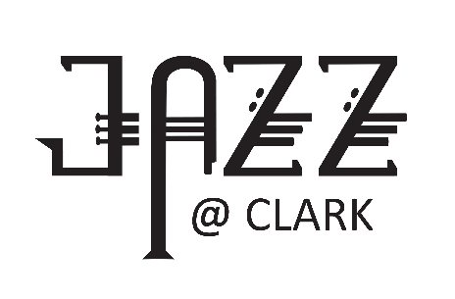

CLARK COLLEGE JAZZ FESTIVAL REGISTRATION

MIDDLE SCHOOL DIVISION
** Use a separate form for each group you are entering **
- Middle School Divisions (AM) . . . . . . . . . . . . . . . . . . . . . .Thursday, January 26, 2023
- Middle School Band Clinic (noon-1pm) – designed for Middle School Band directors and students. Included in registration fee.

PLEASE PRINT CLEARLY
Name of School
Name of Ensemble
Mailing Address of School
City/State/Zip |  |  |  |  | Email
Name of Director |  |  |  |  |  |  | Office Hours
School Phone |  |  |  | Director Cell Required
Check all that apply:
 |  | Middle School competition |  |  |  | Middle School Band Clinic (included in fee)
 |  | Check for non-competitive score |  |  |  | My school can participate in the finals on Thursday evening.
REGISTRATION DEADLINE: December 1, 2022. . . . . . . . . . . .REGISTRATION FEE: $225
Any registrations received after December 1 will be charged a late registration fee of $250.
Registration fees are non-refundable and include 3-day festival admission.
Registration includes admission for director and three other chaperones.
Mail check, made payable to
Clark College Foundation,
and registration form to:
Clark College
Music Department Jazz Festival, BMH 116
1933 Fort Vancouver Way, Vancouver, WA 98663
EMAIL form: sjwilliams@clark.edu
If paying by credit card, please call Shelly Williams at: 360-992-2662

