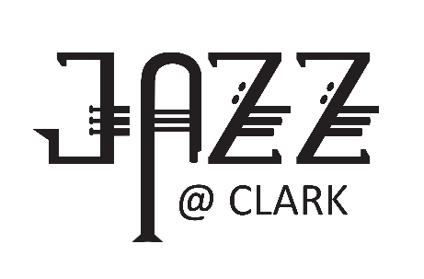

CLARK COLLEGE JAZZ FESTIVAL REGISTRATION HIGH SCHOOL DIVISION
** Use a separate form for each group you are entering **
- A Division (PM) . . . . . . . . . . . . . . . . . . . . . . . . . . . . . . . . . .Thursday, January 29, 2026
- AA Division (PM) . . . . . . . . . . . . . . . . . . . . . . . . . . . . . . . . . . . Friday, January 30, 2026
- AAA (AM) & AAAA (PM) Divisions . . . . . . . . . . . . . . . . . . . . . . Saturday, January 31, 2026
PLEASE FILL IN COMPLETELY
Name of School
Name of Ensemble
Mail Address/School
City |  |  |  | State/Zip
Name of Director |  |  |  |  | Email
School Phone |  |  | Director Cell
Check all that apply: High school size is determined by grades 10-12. You may use younger players but please review the regulations for eligibility.
Please initial that you have read and understand the following:
______Only 25 students may perform at any one time. Bands with more than 25 students performing on a tune will NOT receive a score and will not be eligible for finals.
______Clark College does NOT provide cymbals.
 |  | “A” Division (1-525) |  |  | “AAAA” Division (1201+ and magnet high schools specializing in performing arts)
 |  | “AA” Division (526-1000) |  |  | COMMENTS ONLY (Friday AM Slots ONLY)
 |  | “AAA” Division (1001-1200) |  |  | My band can stay for evening finals (until ~9:30pm)
PAYMENT OPTIONS: One option MUST be selected. Bands will be scheduled when both the form and payment have been received.
PO is attached/or number is:__________________
Clark invoice should be mailed to (provide email address)____________________________________________
Accounting will call with a credit card by December 1, 2025
Check is enclosed (made payable to CLARK COLLEGE FOUNDATION, 1933 Fort Vancouver Way, Vancouver, WA 98663)
REGISTRATION DEADLINE: December 1, 2025. . . . . . . . . . . .REGISTRATION FEE: $250
Any registrations received after December 1 will be charged a late registration fee of an additional $25 (total of $275)
Registration fees are non-refundable and include 3-day festival admission for director and five other chaperones.
For more information: Shelly Williams, sjwilliams@clark.edu or 360-992-2662

