Questions and Answers

ID Numbers/cards/General ctcLink PeopleSoft
Q. In the presentation, you referred to people writing down their “CTCLink ID” number…is this the same as the Emplid? If I have a link from Ryan Paulos that has a UAT Emplid, will this be my permanent ID?
A. The ctcLink ID is also known as the EMPLID. Any ID number that you are currently using in ctcLink for data validation, UAT, building in production, parallel testing, or query building is only a temporary ID. You will be issued a new ctcLink ID when you log into PeopleSoft with your current SID. Please remember to write down your new ctcLink ID, as you will need it to log into ctcLink.

Q. When it is time to get new ID cards, can we have the professional photographer come and take photos to have on the ID card, instead of the security photo?
A. Communications and Marketing provide opportunities for employees once a year to have a photo taken for the directory in lieu of the security photo. The ID card is different and is handled by Security.

Q. I am just checking in to see if there is any intent for the college to update employee ID badges with new numbers. I know we are required to carry them on our person and it has been the practice to scan in at training events so I was just wondering if this is part of a next step for CTCLink?
A. There are no plans at this time to have everyone acquire a new ID badge. As new badges are created they will have your ctcLink ID as the barcode. Scanning systems will still be able to take manual input.

Q. How long will it take to have my password reset.
A. PeopleSoft has the functionality for you to reset your password if you have forgotten it. When you set up your initial password you choose 3 security questions and your answers. You will need to remember those security questions in order to reset your password yourself. If you have forgotten your security questions then you will need to contact the IT Service Center (for employees) or the Tech Hub (for students).

Q. How do we call the student portal in PeopleSoft (e.g. MyClark is the name of the student portal currently).
A. For students we’ll keep referring to it as MyClark

Q. When we get into the test environment and start playing around with the software will the information we put in carry over when we go live on the 30th? Or will we need to start with a blank slate?
A. Data from the test environment does not impact the actual data in production. It will not be moved from test to production at GoLive, now will it have any impact on production after GoLive.

Q. How would I enter my last name for the test site (SVL)? Please help! My last name is hyphenated.
A. Use both last names, capitalize the first letter of each, but no hyphen or space, plus the @ sign. Oswald Clark-Penguin would be ClarkPenguin@

Q. I’ve looked at my employee self-service information and it says I am a smoker. This is incorrect.
A. left side is the category, right side is the answer or response. “ Smoker Smoker “is what indicates you are a smoker. If you only see the work” Smoker” once it is just the category and the answer is blank.

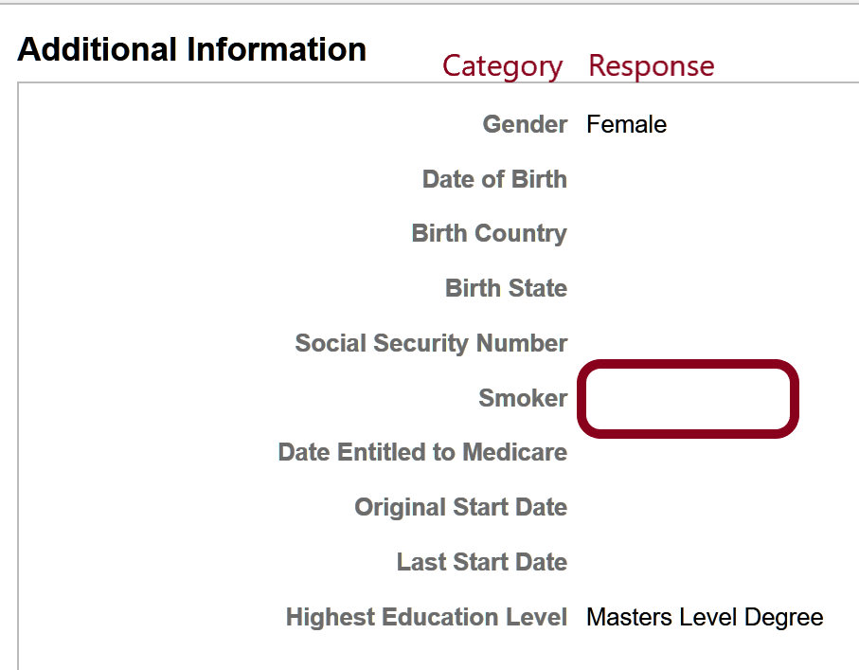
Q. I have heard this complaint from several different people, so just wanted to confirm that this is a setting that we don’t have control over locally, right? I think the warning says 20 minutes.
A. After 18 minutes of inactivity you are provided a warning that lets you know that after 20 minutes of inactivity the system will log you out. You then have 2 minutes to do something in the system or get logged out. This is not anything the college has control over. I’m not sure if this is a global configuration or something based on PeopleSoft or the company that hosts PS – but it’s not changeable.

Q. When Logged into ctcLink and then I try to open the Online Admission Application (OAA) or OSECE for continuing Education registration the links do not take me to the correct locations.

A. Our App Services folks clarified the "real" issue for me, browser cookies, and it is something that we have learned to adjust to when working in Web-Based applications. When you are already logged into PeopleSoft in one browser, it is best practice to open the OAA in a different browser. For example, I primarily use Chrome when in PeopleSoft and if I want to remain logged in while reviewing the OAA, I open up the OAA in FireFox. Otherwise, if I want to use Chrome, I would need to log off PeopleSoft and then log into the OAA. This has become a habit for all of us. This will also be the case when your staff begin using the PCD test environment. It does not always "work" to have both PRD & Production open in the same browser. One will need to be accessed through a different browser or you must log out of one/open the other. In all of the above scenarios, sometimes it will be necessary to clear your cache to get logged back in to where you need to be.

Business Processes in ctcLink
Q. Can the notes which are available to students incorporate information about appeals processes and the status of an appeal?
A. Notes could be used this way. We can also explore other options for making this information available. This will be included in future business process discussions.

Q. Is there any way in PeopleSoft to notify students (e.g. by email, display an announcement/a reminder in the student portal, etc) when they updated their contact information in PeopleSoft?
A. We can set up communications to groups of students based on actions that have taken place in PeopleSoft. Any student communications will need to be incorporated into the Student Communication Plan which is being created.

Q. In SMS currently, AP awarded course credit, such as CS&141, is done by creating the dummy course, enrolling the student and indicating their successful completion. Obviously, this is a BIG NO NO in the new system, so how do we award AP credit.
A. In the test page in ctcLink the score a student received on an AP test will be recorded. These score are then crosswalked to equivalent courses at Clark College and this information is available on the student’s transcript.

Q. Since student email is simply Gmail, can the tech hub just send the student to the Gmail password reset page?
A. I assume they can if the user has set up the password reset information. If they have been using their PIN’s to get their initial GMAIL password, then they will not be able to go to the PW reset page for their initial logon.

Q. Also, for AD password reset, do students get the Office365 password reset with security questions that employees get?
A. The students do need to set up the security questions (or backup phone/email) in Office365, and if they use the Microsoft PW reset page (https://passwordreset.microsoftonline.com/) to reset their password, it will also reset their AD password through password-writeback.

Q. One thing I’m just curious about is that why do some names in PeopleSoft have more details than those in SMS? I thought the values in the combined_roster.csv are the ones that were taken from what we currently have in SMS and converted into PS data. So, it makes sense that the last name, Amsler-Robert, in SMS gets converted into PS as Amsler because it probably lost the “Robert” part due to conversion errors. But, how does the last name, Archudia, in SMS gets converted into PS as Archundia-Orduna?
A. different data sources. Data in PS is not only from SMS, but also PPMS, and Financial Aid data.

Q. Can students continue to log into Canvas with their SID?
A. The plan is to indefinitely maintain the Canvas SID logins for all previous and current students unless there is technical reason to remove it. Most will find the ctcLink access to Canvas preferable, so the SID login will serve as a fail-safe. Beginning Winter quarter, all students who are new to Clark will automatically receive only a ctcLink login for Canvas. The current Canvas login username for students is their SID, and for faculty and most staff, it is their Clark email address. The work for ctcLink will add the MyClark ctcLink (EMPLID) login which will result in two Canvas logins for each current user. In addition, users logged in on MyClark ctcLink should be able to access Canvas without having to login again (Single-Sign-On). The dual Canvas login is necessary as a fail-safe because we are migrating during an active quarter where student coursework could be disrupted. Note also that all new user accounts created after the ctcLink migration will have only one Canvas login, their EMPLID.

Time and Leave / Pay
Q. How is sick leave to be requested, approved, and reported?
A. Sick leave is processed just like other requests for absence through the Request Absence page. Indicate the dates and amount of time used/being used. Absence Requests which are pending approval are displayed for a supervisor on one of their home pages. When your supervisor approves the use of sick leave it will become available for you to use to Report Time. Until an absence is approved by your supervisor, the only time you are able to report is “01 Regular”.

Q. Do I submit class cancellations and sick leave?
A. Class cancelations – where you are having a notice posted to the website is still done using the same process. Submitting a request to use sick leave and reporting the use of sick leave will be done in people soft.

Q. Okay – so, if I’m reading this correctly, if I get sick on Tuesday, I can report that retroactively on Wednesday when I get back, as long as it’s in the same pay period. If, however, I get sick on Tuesday, and Wednesday is in a different pay period, what happens? I have to log in from home to report my sick leave? I report it on a different day so my hours are correct? As I’m reading it, this isn’t that different from what we’ve got now – we report sick leave, and our supervisor double-checks to make sure we’re not under/over reporting our leave.
Leave documentation in ctcLink- if leave has to be put in an approved in advance, what happens with leave that is emergent or if someone plans an hour for an appointment and it actually runs longer? How will this be handled?
A. If an employee requests leave, the manager approves it and the employee ends up taking less or more time than first planned. The employee will submit a revised leave request for the manager to approve. Once the manager approves the timesheet will update to include the change in leave. If for some reason the employee does not submit a revised leave request or is not available, the supervisor can make that adjustment to the timesheet to include leave. Right now TLR only tracks absences and work time but not leave requests. With PeopleSoft, leave requests and tracking work time and absences will be housed in one place.

Q. Vacation – I’m still confused about. Let’s say I plan to take vacation next week. I submit it and my boss approves it. Something at work comes up and my supervisor needs me to work. I can’t work, because my vacation has been approved?
- You are on the right track, you can go back and add in your sick hours from prior pay period, however, with People Soft, we won’t have as much time to go back. People Soft give the employees and/or supervisor a couple of months to add/change leave. If you request vacation and did not take vacation, you or your supervisor can change the leave request.

Q. Are vacation requests saved and able to be accessed by supervisors?
A. Managers will have a Manager Self Service page. Here they will be able to see all the staff they supervise, including requests the employee has made.

Q. How is sick leave to be requested, approved, and reported?
A. Employees can request sick leave through the Absence Management Module in PeopleSoft. Through Absence Management, an employee can request sick leave for future appointments or for hours/days they’ve missed. Once an employee requests sick leave, for future date or previous date, it will go to the supervisor for approval. The supervisor has the ability to approve the request, change hours on the timesheet or reject it back to the employee to make changes. Once the request is approved, absence data will transfer to the employee’s timesheet. The timesheet will have sick and vacation hours that are imported from Absence Management. Through PS, the employee does not report sick leave, instead they request the time off through Absence Management.

Q. Are vacation requests saved and able to be accessed by supervisors?
A. Yes, vacation requests are always available to view by the employee and the supervisor. Both the employee and the supervisor can view and make changes, as needed. However once requests are approved and processed they cannot be changed.

- Do I access paystubs?
A. Yes – you will find those in your employee self-service page.

- If faculty have a single contract for teaching and they receive a stipend to complete additional work will this impact their contract, will they have two contracts?
A. Stipends are paid out of the unit budget. This would be paid separately, possibly through FWL or as additional pay in Payroll.

Q. When/how are staff supposed to update payroll information in ctcLink such as direct deposit information?
A. There will be training offered on how to do this. And Payroll will still be able to enter this data for employees if they want us to. There are concerns about lacking a double verification process in making sure that direct deposit is configured correctly. There will still be a pre-note/test transaction and a paper check for the pay date when the change is made (same as current), if there is an error the receiving bank reports this and we contact the employee (same as we do now).
Q. Where is the “save” button on time & Leave
A. There is no save. Use the submit. This sends a notice to supervisor, but also saves your information.

Q. Only one paycheck is available in ctcLink. Where can I find my other paycheck information?
A. The only checks available in ctcLink will be those for payrolls processed in ctcLink. Prior paychecks remain available through the old system.

Q. I get an email telling me to go to approve, but when I click on the link it does not work.
A. Treat this as a notification that you should go into PS and look for notifications. This is a known issues which is being worked on.

Q. I’m seeing other people’s email address, such as “An error occurred while trying to deliver the mail to the following recipients: blanier@tacomacc.edu”
A. This is a known issues which is being worked on. This looks like a staff member at Tacoma, but is actually a SBCTC staff member who was doing some testing.

Q. My employees that hold multiple jobs or multiple positions are unable to decipher which to use with which position/job to create a time sheet.
A. Please contact HR and they can help you decipher these jobs. We are working on slightly more helpful descriptions.

Q. I’m getting an error on my time sheet: Time reporting code is required ** Ensure the field is filled in with a value. What does this mean?

A. You get this error anywhere in ctcLink PeopleSoft when you add a row, by clicking on the + sign and then leaving the row of data empty. You can click on the – sign to remove the row and then save.

Course and Class
Q. Should our schedule dates that student see in PeopleSoft include exam week?
A. Currently we do not include exam week, so this will not be a change for students. There is functionality in PeopleSoft which is tied to the dates displayed, so it must remain the 10 week instructional period.

Q. As an adjunct, do I access class rosters on this site?
A. All instructors will access their class rosters through the faculty center in ctcLink PeopoleSoft, this includes adjuncts.

Q. Do I post Grades or still use “Instructor Briefcase”?
A. Yes – in the faculty center (which replaces Instructor Briefcase) you will have class rosters. You will be able to send communications to students from the list, report Early Alert concerns, and post grades.

Q. I just noticed that the online English courses for Winter 2020 are showing that the Days/Times are TBA. Is this a mistake or something that can be changed? I can see students being confused by that and not enrolling thinking there could be face-to-face meeting times.
A. Unfortunately, when we list “online” this auto populates TBA. We are working with SBCTC to change this.

Travel and Expenses
Q. Where is approval after the travel is submitted?
A. Travel Authorizations and Expense Reports can be located in the Financials Self Service. You can create, modify, delete, print, or view your requests.

Q. More clarification on the travel process.
A. If you are an employee who needs to travel you will submit a Request for Travel Authorization. Supervisors will approve the request. You may also request a Travel Advance. When you have completed your travel you will then submit the details of your expenses.
The process is very similar to the current process, except that paper forms are being replaced by processing everything in PeopleSoft.

Q. How do I submit an expense report for a travel authorization that was approved before the ctcLink cutoff?
A. If your travel authorization was submitted either in Procure or on the old paper form prior to the cut off, we ask that you process your expense report using the old paper form. Outstanding travel authorizations were not entered into ctcLink and therefore there is no way to track them if you were to enter them in ctcLink. So, if you started it the “old way” then you should finish it up the “old way.”

- What if I need to make a change to a previously submitted travel authorization?
A. If changes to previously approved travel authorizations need to be made, please contact Brenda Shular in Purchasing directly via e-mail.

Q. How do I know I need to approve a travel authorization?
A. ctcLink has the ability to send e-mail notifications to approvers to notify them when something has been submitted for their approval. The easiest way to determine if you have any pending approvals is to look in Approvals section. You can get there through the Navigation Bar.

Q. Can I submit a cash advance in ctcLink?
A. ctcLink will allow to create a cash advance wtihout a travel authorization but this is NOT the acceptable method. In order to be approved, Cash Advances must be created from the Travel Authorization before it is submitted for approval.

Q. Please see the info below. This looks different than what I have traditionally seen, and when I clicked the link, I was unable to approve. I just want to make sure this is legit, as these PeopleSoft approval requests have typically come to me from the employees email address.
From: Oracle Expenses Email Approval System <exmcprocessor@sbctc.edu>
Sent: Tuesday, November 19, 2019 3:32 PM
Subject: [EXTERNAL] Expense Report "0000014644" has been sent for your Approval.
A. This is a genuine notification from the ctcLink PeopleSoft system. This is the address expense approvals may be sent from.

Go Live Questions
- When will the link actually be active?
A. October 28th is our GoLive date. Faculty will have access on Tuesday the 29th. IBC will remain up so you can still access your rosters, however drops and adds after 10/17 would not show in IBC.)

Q. Can blanket PO’s be used in October?
A. Yes they can.

Q. When will students get their Emplid?
A. Students will be able to log into ctcLink beginning Thursday, October 31st. They will log in using their current SID, name, and date of birth. Once they set their security questions and password they will be provided with their new ctcLink ID (sometimes known by those working in the project as EMPLID). Students need to write down this ctcLink ID so they can access the new system.

Q. Is Advising Services part of the SuperUser group, getting access on Monday? If not, can we be added to the Monday group so we have time to familiarize ourselves with the system as early as possible?
A. Advising staff, along with anyone who currently does processing in the legacy system, will be part of the group of employees accessing the system on Monday.

Q. Tutoring Services has sign-in kiosks in all centers that connect to live SMS data. Will these kiosks not be functional for the two week period during transition or will they continue to function?
A. The short answer is, the Tracking System will continue to function during the two-week transition period.

The long answer is, the plan I have for Tracking System for now is that it will get transitioned to use the PeopleSoft data in Winter (i.e. Tracking System will run based on the SMS data throughout the fall quarter). So, the system still accesses the snapshot of the SMS data, and I believe it should be fine because SMS already has all students’ data for fall quarter.

A few possible problems we may have during the Fall quarter are:
- If a new student/employee gets entered into PS after goLive, Tracking System won’t know about the student
  - If you could send me the name or EmplID, I can manually enter into the database
- Students/employees will not be able to sign in with their new EmplID in Fall
  - They can still scan the ID card, sign in with the legacy SID, sign in with the computer login username

After goLive, Tracking System should accept all the following ID types
- the legacy SID (i.e. Scanning ID cards)
- the new EmplID
- Computer login username
and the new version will be available sometime in the Winter break.

- What if staff are not paid on time after go-live? Will there be paper checks provided?
A. Yes.

Q. What if I have a trip that has not been approved that is scheduled for this week?
A. Due to the backlog in Purchasing and the learning curve for both travelers and approvers, we ask that you submit an old paper form to get your travel approved. This is for travel within the next week ONLY.

