How Create a Signature for DSS ROI
- Select signature field
- Select “Create a New Digital ID”, then select “Continue” button
- Select “Save to File” option, then select “Continue” button
- Enter Name and email address in the two required fields, then select “Continue” button
- Create and confirm password, then select “Save” button
- Select your Digital ID, then select “Continue” button
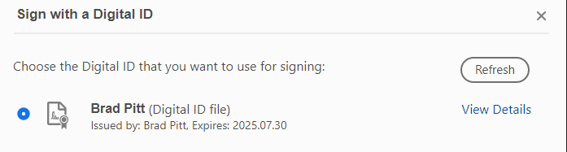
- Enter password, then select “Sign” button
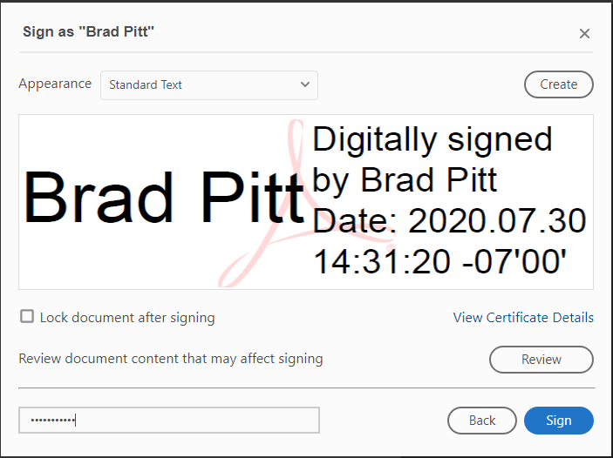
- Save as dialog box opens – save file to desired location
- Signature appears in signature field
