DSS Faculty Portal Guide
Faculty will continue to receive accommodation letters emailed for each individual student in each class. The Faculty Portal allows instructors to log in and view all student accommodation letters in one place for the term. Or if faculty want to ensure they have not missed a student letter, they can log in and check.

How to get in:

Log in Link: https://teton.accessiblelearning.com/Clark/Instructor

Username & Password: The Faculty Portal uses Single Sign On. Your username is the same as your full Clark email address. Example: Someone with the email address OPenguin@clark.edu. Your password is the same as your Clark Email password.

Instructor Authentication Page
When you have successfully logged in, you will be brought to the “Instructor Authentication Page”. Click “Continue to View Student Accommodations”.
Note: Even though there is an option to “sign in” in the upper left corner, do not click on this link. You are already signed in to the faculty portal.
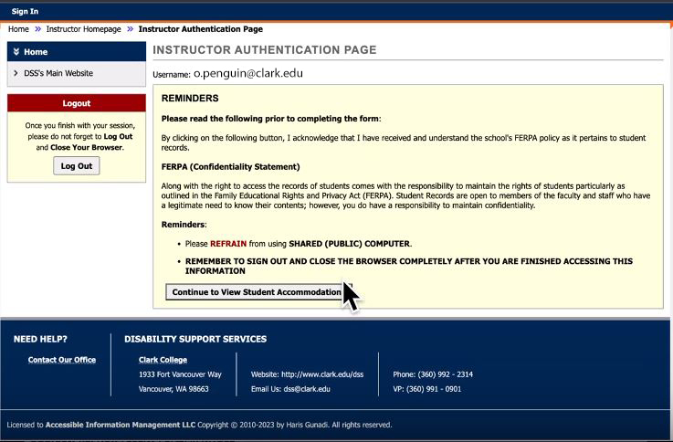

List of Student who Requested Accommodation
On the next screen, you will see a list of all of the students who have requested accommodations in your classes. You will be able to see at a glance if they have Testing Accommodations, use Deaf/ Hard-of-Hearing services, have Notetaking services, or if they use Accessible Formats. These are not the only accommodations that students might have, but they are they most common ones.
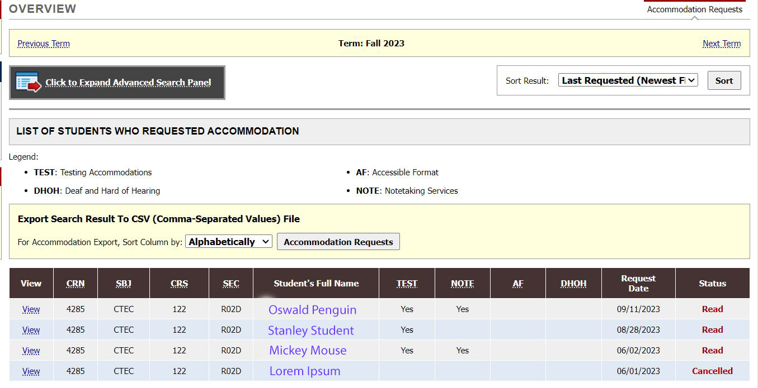

Notification Letter
To view a Faculty Notification Letter for a specific student, click on “View”. This is the same information that you receive in the Faculty Notification Letter emails.
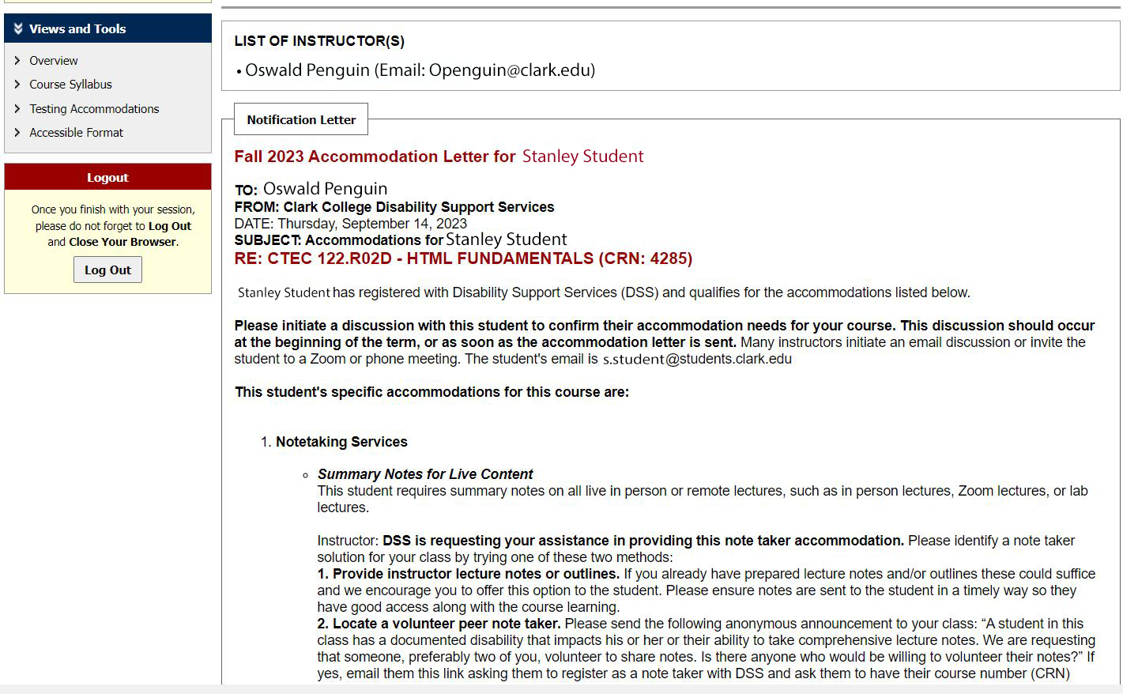

Testing Accommodations
If you have students with testing accommodations in your classes, you will be able to fill out the testing contract for each of your classes within the faculty portal. Select the “Testing Accommodations” option on the left side of the screen. You will have a screen with a drop down menu that allows you to chose the class you want to fill out the alternative testing contract for.
