Interpreter’s Guide to myDSS

How to Log into myDSS

myDSS is the online system that students with disabilities use to request and track their accommodations, while attending Clark College and working with Disability Support Service. It is also the system that is used to send out jobs and track hours for interpreters.

Once hired, you will be entered into the system so that you can see assignments and details for work at Clark College. The username will generally be your first initial and last name, no spaces. You’ll receive an e-mail that contains your username and temporary password to the email address you provide. Once you log into myDSS with your temporary password, you can change the password under 'Change My Login Information'.

If you need a new temporary password assigned to you, please use the “Reset My Password” link (under the My Dashboard tab) to have a new one sent to your email. If you still experience password difficulties, please contact the interpreter coordinator.

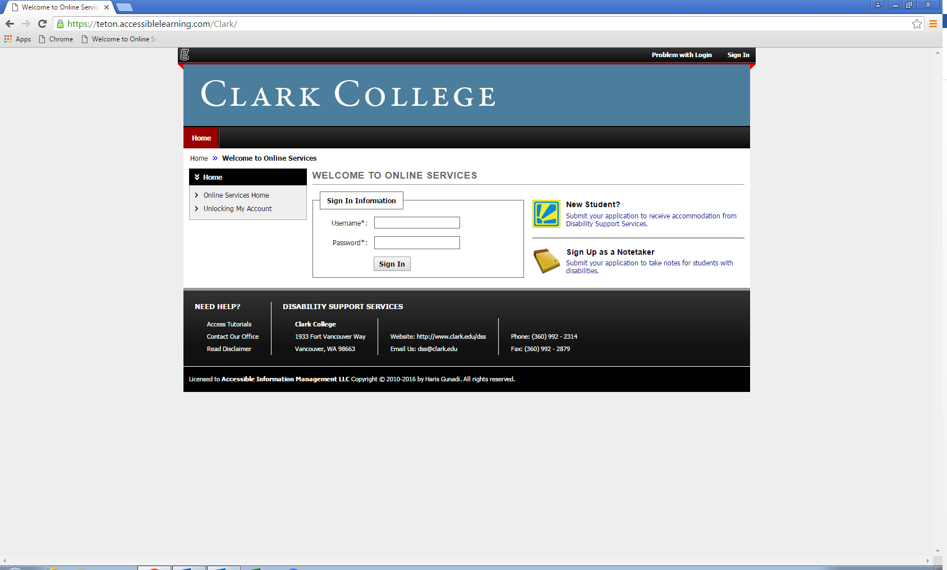

How do I see my assignments?

Once you are confirmed to an assignment, you will have access to the assignment details in myDSS.

First, you will need to log in to myDSS. Once you sign in, you will see your Interpreter Home page:

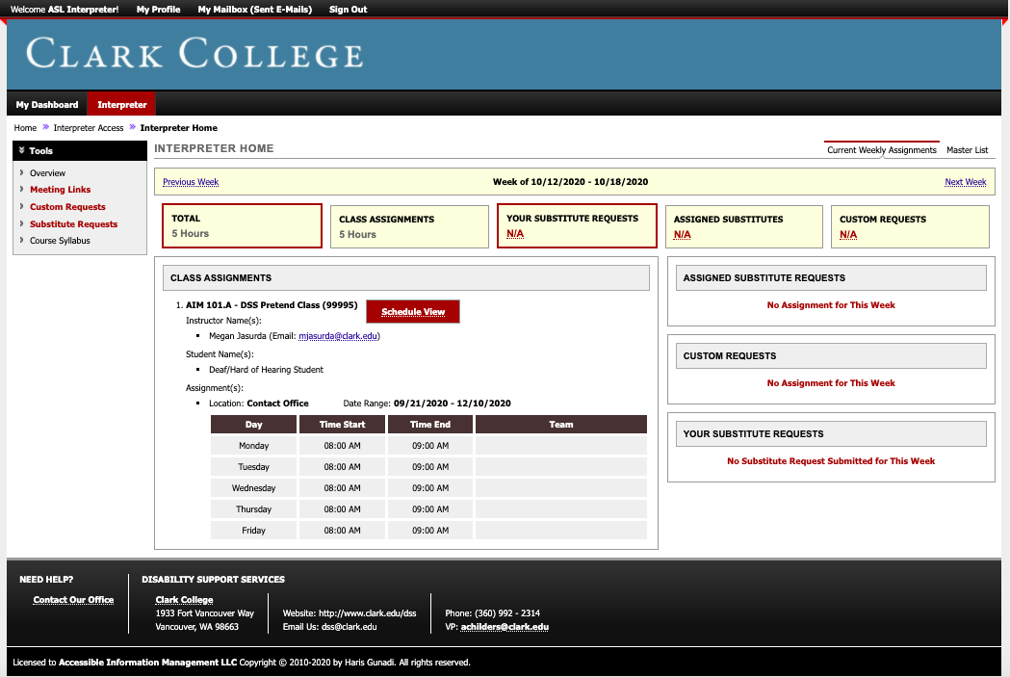

Here you will see the overview page for any ongoing class assignments, assigned substitute requests, custom requests, and the substitute requests that you submit. The assignment details, such as class name, student name, instructor name and email, location, date range, and class dates will be made available under the class assignments.

If you’ve been assigned to a custom request you will see the Requestor name, Event Name, Speaker(s), Event Date, Time Range, Location, Request Type, Media Used, Staff Assigned, and Employee Note. If you have any questions that are not answered by the assignment details provided reach out to the interpreter coordinator.

You can use the ‘Next Week’ and ‘Previous Week’ links to navigate through the weeks. This may be helpful for you when you fill out your time sheet on CTCLink. Please note that myDSS records the exact time of the class. When you bill be sure to record to the nearest 15 minute after the class ends. For example, if a class is from 1-3:20pm you would record 1-3:30pm on your timesheet.

You can use the ‘Master List’ tab to see on-going class assignments for the entire term but be aware that any custom request you have been assigned to will not populate in that view. For a comprehensive view of custom requests for the term use the ‘Custom Requests’ link on the left-hand navigation pane.

How do I submit a substitute request?

If you know in advance (i.e. vacation, appointment, etc.) that you will need a substitute interpreter for your class, request a sub through myDSS as soon as possible.

You cannot request a sub for a custom request or a class that you are subbing in, so you will need to contact the coordinator if you need a sub for either of those scenarios.

On the interpreter home page, you’ll go to the left side navigation pane and click on ‘Substitute Request.’

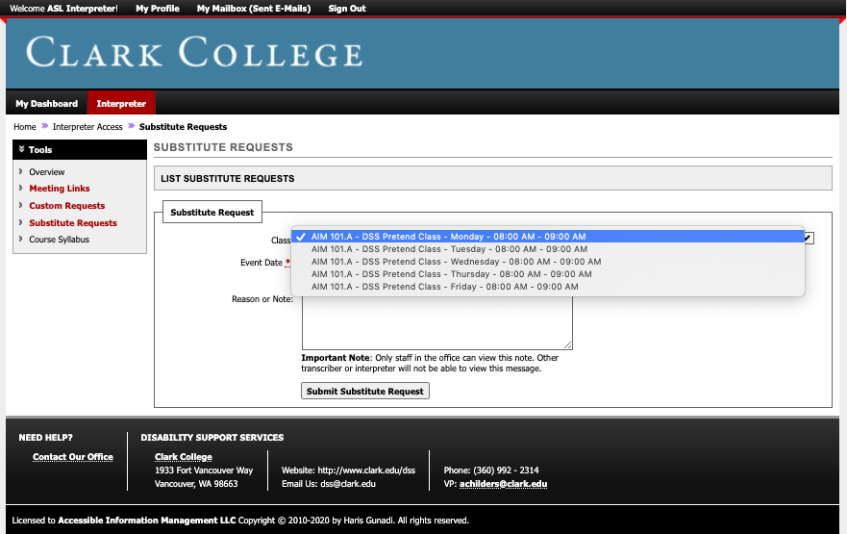

There will be a drop-down menu by the class, you need to select the calendar day for the date that you need to request a substitute interpreter. For example, if you need Monday, October 19, 2020 off from class then you will select the class name that has Monday from the list in the drop down menu. Next you’ll enter the ‘Event Date.’ Finally, click ‘Submit Substitute Request.’

Please note, if you enter a date that does not correspond to the calendar day the system will issue an error message and your request will not be go through. Additionally, if you have multiple classes on the day that you need a substitute you need to submit a substitute request for each class.

Once your substitute request has been submitted it will show up on the page as shown in the example below.

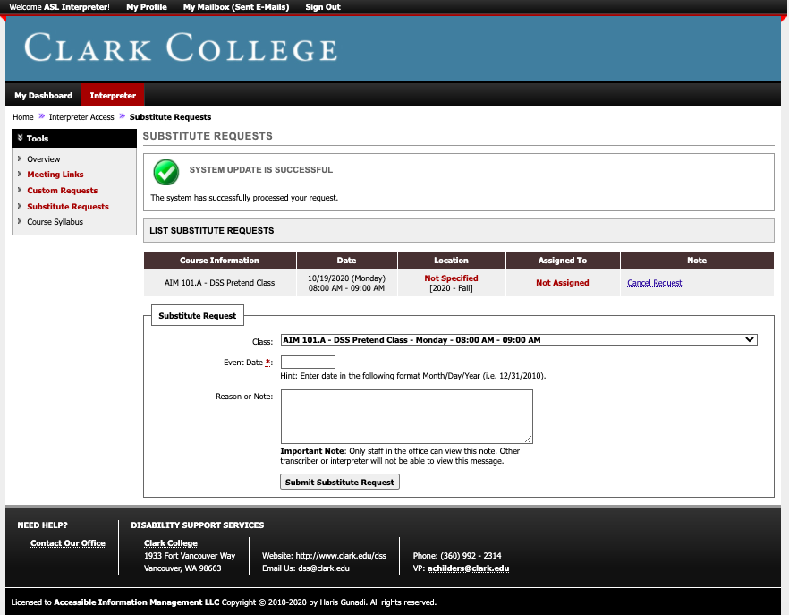

If for some reason you no longer need a substitute for your class, there is an option to ‘Cancel Request.’ You will also be able to see who the assignment is assigned to. Please note, if the interpreter coordinator has assigned the class to another interpreter the ability to cancel the request on your own will no longer be available. Please reach out to the interpreter coordinator about any changes to already assigned substitute requests.

