This guide is a resource for my sign language interpreter colleagues working remotely from home. I am a staff ASL/English interpreter at Microsoft with 14 years of professional video remote interpreting (VRI) experience in both workplace and home-based settings. I enjoy supporting other interpreters through the troubleshooting process, and I hope that you find this guide helpful.
Topic | Details
PRIVACY | - Designate a space in your home for interpreting, ideally a room with a door. (Some employers require a door, unless you live alone without pets.)  - Use a headset. (more on that below)  - If others living with you are still able to hear your calls, get them a pair of noise cancelling headphones.  - Keep pets away while you’re on a call.  - Mute the microphone on any home assistant devices; silence your phone.  - Turn off anything noisy that might auto-run while you’re working. (robot vacuums, for example)
BACKGROUND | - Use a solid colored background. Paint a wall or use a pop-up video backdrop (search online) or hang a neat, ironed sheet.  - Choose something that contrasts your skin tone well. Grays, light blues (ocean or royal) work well.  - Avoid white and dark (navy blue/black) colored backgrounds.  - Minimize the clutter in your background; make it crisp and clean. Not only is it a more professional appearance, but it helps to transmit your picture through the network more clearly.  - Dress appropriately for your background; avoid blending into the background.  - Frame yourself well in the picture, considering your signing space. You should be framed like a TV anchor person.  - Get feedback from your consumers on your picture. Adjust as needed.
LIGHTING | - My overall recommendation is to think like a photographer and carefully control the lighting in your room.  - Use a dimmer switch to soften the overhead light to avoid giving you a halo.  - Use cool white light bulbs or color changing bulbs (like Philips Hue) set to bright white/slight blue.  - Avoid shining lights directly at yourself, unless using a diffuser. (parchment paper taped onto a lamp works!)  - Light up your face indirectly with a lamp on your desk, aimed at a white wall or poster paper close by. (on a chair, perhaps)  - A “Happy Lamp” is a nice multipurpose device that is also good for lighting your face.  - Blackout curtains can be very helpful. Be mindful of the daylight coming into your space during a meeting.
INTERNET | - It is worth having a hard-wired connection even if you have to run a cable across the floor. If your computer doesn’t have an ethernet port, use a USB to ethernet adapter.  - If connected via WiFi (not ideal), try to be in the same room as the router. Limit the number of walls and metal objects (like a fridge) between you and the router.  - Fiber-optic (1Gig) internet is best, if available in your area  - Cable internet is good, but can be affected by high usage in your coverage area. Cable providers prioritize download speeds over upload speeds. Check with your provider about increasing your upload speed if needed. Minimum of 10Mbps upload speed is recommended.  - If others are on your home network, make sure they limit internet usage while you work (no video streaming). If this is a constant issue for you, set your laptop as a priority device on your router.  To test your speed: https://www.speakeasy.net/speedtest/
COMPUTER | - PC or Mac? You shouldn’t have a problem connecting either to most video conferencing software.  - Here is a list of computer requirements for video conferencing on an app like Microsoft Teams.  - Keep up on computer software updates, reboot your computer regularly.  - A laptop dock can be very helpful. One plug and you’re connected to hard-wired internet, keyboard, mouse, monitor and headset.  If you have an older computer, reboot before connecting. Shut down all unnecessary apps.
WEBCAM | - Most built-in web cams on modern devices are fine.  - Use an external webcam if you have a desktop or an older laptop. Turn off auto-focus.  If your camera light changes constantly while you sign, turn off auto-white balance. If you do not have access to this feature, include something white in your background to trick the camera.
OTHER DEVICES | - Have a backup device handy in case of unexpected computer issues. (Another laptop, iPad or cell phone)  - An external monitor connected to a laptop is really useful for viewing slides/prep material during a call
HEADSET | - Use a headset. (consumer privacy and audio/mic clarity)  - USB or 3.5mm audio jack is more stable, but a Bluetooth headset will also work.  - I recommend a comfortable, cordless binaural/stereo headset with microphone boom (opposite your dominant side) and easy mute functionality. They’re not cheap, but worth the investment.  - I avoid using noise cancelling over-the-ear headsets because I can’t tell how loud I’m talking.  - In a pinch, earbuds will do the trick. Just be sure you have a plan for quickly unmuting yourself.  Keep yourself on mute when possible unless the meeting is interactive. When you are off mute, be mindful of your mouthing/vocalizations while signing.
PHONE | - A desk phone is not necessary, but I use a landline for phone calls. I like having dialing buttons for conference calls, audio quality is cleaner, and it frees up my cell for texting/video with consumer.  When using your cell phone to connect to a call, turn off notifications to minimize interruptions.
ERGONOMICS | - Set your laptop on top of few books or a laptop stand. Find a height that allows you to sit at a comfortable posture that frames you well in the picture. Your neck will thank you.  - Standing/adjustable height desks are great…especially with a pair of compression socks and an anti-fatigue floor mat.  Practice self-care. Video interpreting, especially while seated, can be hard on the body. After a call, step away from the computer, walk around, look out the window, stretch, drink water.
CONNECTING WITH DEAF CONSUMER | - Follow the Deaf person’s preferred method of connecting to the meeting. Some consumers prefer the interpreter to join the conference call with video on, visible to all participants. Others prefer to connect with the interpreter outside of conference call on a separate video app, joining the meeting with audio only.  - A pre-conference with the Deaf person is a great idea. Get names of participants and vocabulary ahead of time if possible.  - On conference call apps with multiple people, “pin” the Deaf person’s video to your screen. (right click on their picture)  - If you’re connecting to an app for the first time, take the time to learn the basics or find an online tutorial. (consider it prep!)
TEAMING WITH OTHER INTERPRETERS | - Working with another interpreter (teaming) on a video call requires a little advance planning, but it’s totally possible.  - If you are both joined into the conference call, I recommend that only the working interpreter has video on. If you need to actively support one another with feeds, consider using a separate video app (e.g. via cell phone or tablet) to connect with each other.  - Microsoft Teams, Skype, Zoom, Facetime and Duo can handle video calls with multiple participants.
TIPS | - Tech issues can and will happen, even to those who are well prepared. Keep calm and be flexible.  - Check your audio and video well before connecting so you have time to resolve any issues. Many apps have useful test call features.  - Practice using the common video platforms with other interpreters. Get familiar with the features while you’re not in the hot seat.  - Make sure you have a way to text chat with Deaf consumer just in case you get disconnected on video.  - Keep an eye on your picture periodically throughout the meeting. Keep yourself framed well.  - While interpreting, clear indexing of speakers is critical; use lots of role shifting, but avoid turning your body too far from camera.  - Many video conferencing applications have a participant list. Keep it on your screen during the call to identify who is talking.  - A small dry erase whiteboard is handy.  - Finally, recognize that it is challenging for everyone to work remotely. Proceed with empathy and commit to doing your best work, making the process a little easier for others. Follow blogs and posts written by Deaf people about their experience working remotely. Here are a couple examples: Learnings from Remote Experience: Work It Like A Deaf Person and Accessibility Tips for a Better Virtual Meeting Experience.

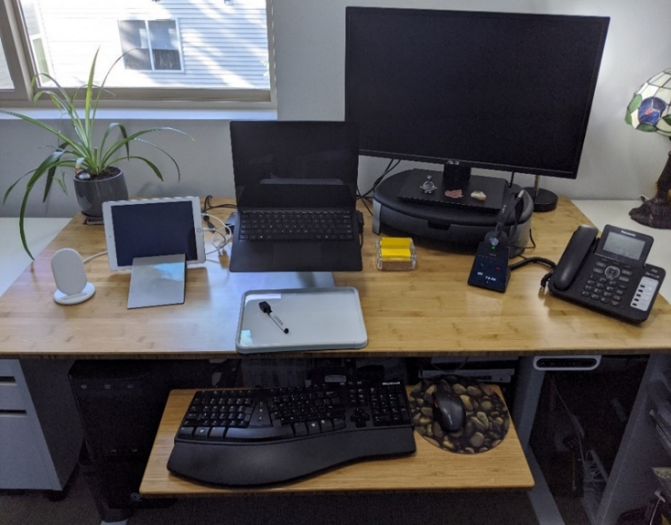
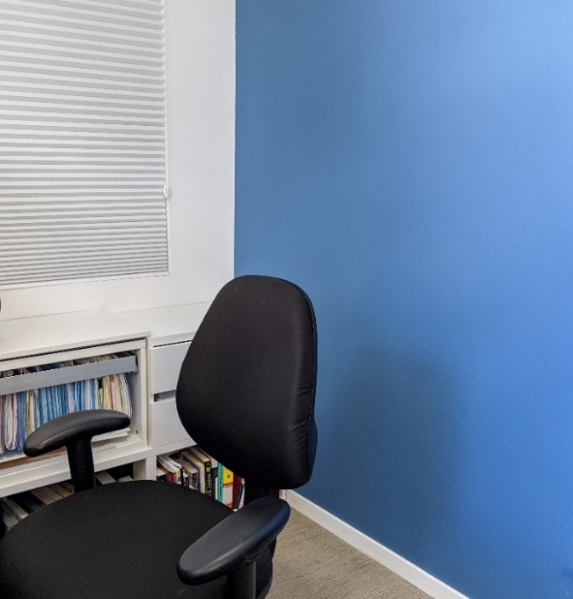
Here is what’s on my desk: PC laptop, external monitor, iPad, headset, landline, keyboard, mouse and a whiteboard.

Here is my background: cornflower blue paint with file cabinet along the side wall and black office chair in center.

