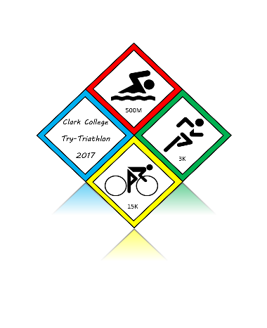 | Penguin Try Triathlon Entry Form

Entry Fees
$30 Individual Entry
$50 Team Entry
(Payment can be made at the cashier’s office, bring receipt of payment and completed entry form to OSC 141.)

Individual/Team Captain Entry
Name: | ☐Male ☐Female  Age: T-Size: S M L XL
Email: | Clark Affiliation:  ☐Student ☐Faculty/Staff ☐Alumni ☐ Family Member
Phone: | Swimming Experience:  ☐Beginner ☐Intermediate ☐Advanced  Cycling Experience:  ☐Beginner ☐Intermediate ☐Advanced  Running Experience:  ☐Beginner ☐Intermediate ☐Advanced
Emergency Contact Name & Phone:

Team Entry
TEAM NAME: |  | ☐Students ☐Faculty/Staff ☐Alumni ☐ Family Members
Swimmers Name: |  | ☐Beginner ☐Intermediate ☐Advanced
Cyclists Name: |  | ☐Beginner ☐Intermediate ☐Advanced
Runners Name: |  | ☐Beginner ☐Intermediate ☐Advanced
I understand that participation in Clark College Intramural Sports & Activities involves inherent risks of injury, and that the nature of the risks may vary depending upon the type of activity, instructor, and my own physical condition and conduct. I also understand that it is not possible to specifically list each and every individual risk. Some activities may expose participants to risks including but not limited to: participation in strenuous exercise; off-campus facilities and locations; activities governed by “rules of the road,” road hazards, uneven outdoor surfaces, vehicle traffic, travel to and from events/locations; exposure to allergens or pathogens, dehydration, animals, effects of weather/environment, acts of nature; cuts, scrapes, bruises, blisters, teeth damage, skin/muscle/bone/joint, head injuries, hernia injuries, lack of rapid responding medical assistance, pool maintenance by an outside agency, choking, drowning, swimmer’s ear (swimming), stabbing (from broken fencing weapon--uncommon), crush and blunt force trauma, actions of other participants, collision with other participants or equipment/implements, exhaustion, falling, fainting, and/or death.
I release Clark College, and the employees, agents, or representatives of Clark College from any and all liability, claims, costs, expenses, injuries, or losses including those resulting from acts of negligence by Clark College that I may otherwise sustain as a result of my participation in or use of the programs, services, facilities, and equipment of the Fitness Center open hours, ASCC Intramurals, and/or open gym times. I also release Clark College from loss or damage to my person or property caused by other users of the Fitness Center, ASCC Intramurals, and/or open gym. Please be advised that Clark College does not provide medical insurance for students. If you are injured during this activity the College will not cover your medical expenses. If you are injured, you will be personally responsible for your own medical expenses, and due to the nature of this activity, it is highly recommended that you have medical insurance.
Signature:____________________
Team Member Signatures:_______________ ___________________

