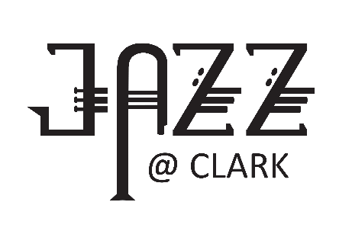

CLARK COLLEGE JAZZ FESTIVAL REGISTRATION

HIGH SCHOOL DIVISION
** Use a separate form for each group you are entering **
- A Division (PM) . . . . . . . . . . . . . . . . . . . . . . . . . . . . . . . . . .Thursday, January 25, 2024
- AA Division (PM) . . . . . . . . . . . . . . . . . . . . . . . . . . . . . . . . . . . Friday, January 26, 2024
- CLINIC (Michele Fernandez) . . . . . . . . . . . . . . . . .Friday @ 1:00 p.m. January 26, 2024
- AAA (AM) & AAAA (PM) Divisions . . . . . . . . . . . . . . . . . . . . Saturday, January 27, 2024
Bands will be scheduled when both the form and payment have been received.
PLEASE PRINT CLEARLY
Name of School
Name of Ensemble
Mailing Address of School
City |  |  |  | State/Zip
Name of Director |  |  |  |  | Email
School Phone |  |  | Director Cell
Check all that apply: High school size is determined by grades 10-12. You may use younger players but please review the regulations for eligibility.
 |  | “A” Division (1-525) |  |  | COMMENTS ONLY (Friday AM Slots ONLY)
 |  | “AA” Division (526-1000) |  |  | CLINIC on Friday (included)
 |  | “AAA” Division (1001-1200)
 |  | “AAAA” Division (1201+ and magnet high) |  |  | My band can stay for evening finals (until ~9:30pm)
REGISTRATION DEADLINE: December 1, 2023. . . . . . . . . . . .REGISTRATION FEE: $250  Any registrations received after December 1 will be charged a late registration fee of $275.  Registration fees are non-refundable and include 3-day festival admission for director and three other chaperones. |  |  |  |  |  |  |  |  | schools specializing in performing arts)
Mail check (with form), made payable to
Clark College Foundation,
Clark College
Music Department Jazz Festival, BMH 116
1933 Fort Vancouver Way, Vancouver, WA 98663-3598
EMAIL form: sjwilliams@clark.edu
If paying by credit card, please call Shelly Williams at: 360-992-2662

