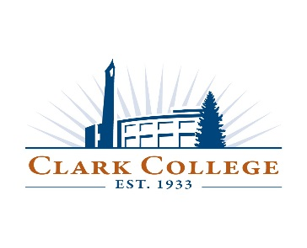
Worker Retraining Advisory Committee
Meeting Agenda
Friday, April 17, 2015
Joan Stout Hall, Room 120
11:30 a.m. – 1:00 p.m.

LUNCH SERVED

- Approval of Minutes from Winter meeting

- Welcome, introductions and agenda review – Chair, Darcy Altizer

- Student Testimony – Brian Schoonover

- Changes/updates on 2015-16 Worker Retraining Program – Rebecca Kleiva

- Overview of proposed 2015-16 Program Mix for WRT grant – Rachele Bakic & Cathy Sherick

- Potential new members for 2015-16 – All

