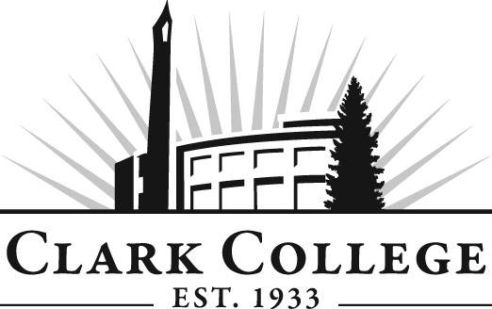
Professional Baking Advisory Committee
Meeting Agenda
Date: Tuesday, May 19, 2015
Time: 2:30—4:00 p.m.
Meeting Location: Baking Lab

Agenda Item | Expected Outcome | Time
- Call Meeting to Order – Committee Chair | N/A
- Welcome and Introductions – Committee Chair | New members/guests introduced | 5 min.
- Approval of Minutes from Last Meeting – Chair  - February 17, 2015 | Corrections indicated and/or approval of minutes as written. | 5 min.
- Office of Instruction Updates- Advisory Committee Business-  - Advisory Breakfast recap  - Fall chair/vice chair training  - Clark College Strategic Plan |  | 10 min.
- Director/division chair Report  - New curriculum  - Program teach out  - Staffing |  | 15 min.
- Work Plan-Committee Chair and Program Director/Division Chair | Review work plan. Implement strategies as outlined in work plan. If necessary, identify work groups. | 40 min.
- Old Business-Follow-up- Committee Chair |  | 10 min.
- New Business  - Election of Officers | New business items are addressed by the committee. | 20 min.
- Summary of follow-up action items – Committee Chair | Summary of follow-up actions communicated to the committee. | 5 min.
- Establish next meeting date and adjournment – Committee Chair | Meeting date established. | 5 min.

