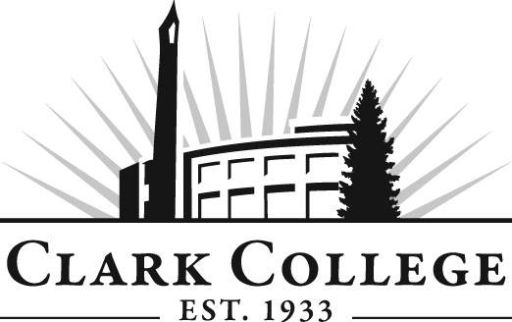
Professional Baking Advisory Committee
Meeting Agenda
Date: Tuesday, February 17, 2015
Time: 2:30 p.m.
Meeting Location: Gaiser Chocolate Lab

Agenda Item | Expected Outcome | Time
- Call Meeting to Order – Committee Chair | N/A
- Welcome and Introductions – Committee Chair | New members/guests introduced | 5 min.
- Approval of Minutes from Last Meeting – Chair  - November 18, 2014 | Corrections indicated and/or approval of minutes as written. | 5 min.
- Office of Instruction Updates- Advisory Committee Business-  - Committee roster  - Advisory Committee Recognition event – Weds., March 18, 2015, 7:30 a.m. – 9:00 a.m. Regional economist Scott Bailey will be guest speaker |  | 10 min.
- Director/division chair/Dept Head report  - Clark College Culinary Academy.  - Curriculum update. |  | 15 min.
- Work Plan-Committee Chair and Program Director/Division Chair | Implement strategies as outlined in work plan. If necessary, identify work groups. | 30 min.
- Old Business-Follow-up- Committee Chair  - Remodel update. |  | 20 min.
- New Business  - Committee membership. | New business items are addressed by the committee. | 20 min.
- Summary of follow-up action items – Committee Chair | Summary of follow-up actions communicated to the committee. | 5 min.
- Establish next meeting date and adjournment – Committee Chair | Meeting date has been established.  May 19, 2015 | 5 min.

