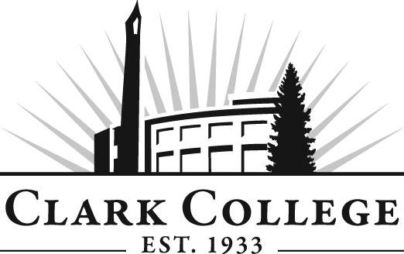
Nursing Education Advisory Committee
Meeting Agenda
Date: Monday, May 18, 2015
Time: 8—10 am
Meeting Location: CCW – Room 122 & 124

Agenda Item | Expected Outcome | Time
- Call Meeting to Order – Committee Chair | N/A
- Welcome and Introductions – Committee Chair | New members/guests introduced | 8:00-8:05
- Approval of Minutes from Last Meeting – Chair  - February 23, 2015 | Corrections indicated and/or approval of minutes as written. | 8:05-8:10
- Office of Instruction Updates- Advisory Committee Business-  - Advisory Breakfast recap  - Fall chair/vice chair training  - Clark College Strategic Plan |  | 8:10-8:20
- Director/division chair Report  - Events of National Nurses Week: SNACC Representative  - Inter-professional Education  - Budget  - NCLEX pass rates (Jan-March 2015)  - NAC pass rates  - Pinning ceremony Class #120 |  | 8:20-8:50
- Work Plan-Committee Chair and Program Director/Division Chair | Implement strategies as outlined in work plan. If necessary, identify work groups. | 8:50-9:10  Break:  9:10-9:20
- Old Business-Follow-up- Committee Chair  - ACEN focused visit – Cindy Myers  - DTA/MRP – Angie Marks  - HeW Grant-Adriana Thomas |  | 9:20-9:35
- New Business  - Elect vice chair | New business items are addressed by the committee. | 9:35-9:45
- Summary of action items – Committee Chair | Summary of follow-up actions communicated to the committee. | 9:45-9:50
- Establish next meeting date and adjournment – Committee Chair | Meeting date established. | 9:50-10:00

