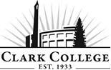
MECHATRONICVS ADVISORY COMMITTEE - MINUTES
Tuesday, October 16th, 2018 * 6:00-8:00pm
CTC, Room 202

Members Present: Zeb Hallmark, Analog Devices (Committee Chair); Silviu Spiridon, Analog Devices (Vice Committee Chair); Steven Park, Analog Devices; Dan Wahlstrom, Simonds International

Members Absent: Chris Taylor, Daimler Trucks North America;

Clark College: Chris Lewis, Department Head; Ken Luchini, Roger Godsil, Instructors; Renee Schiffhauer, Associate Director of Advising; Wende Fisher, Educational Planner – Advising; Francois Wevers, Director of Economic Partnerships and Customized Learning (ECD); Cathy Sherick, Associate Director of Instructional Planning and Innovation; SueAnn McWatters – Program Specialist – Advisory Committees
______________________________________________________________________________

Zeb Hallmark called the meeting to order at 6:06pm and introductions were made.

  - APPROVAL OF PREVIOUS MEETING MINUTES

The minutes of April 24th, 2018 were presented: Zeb Hallmark made a motion to approve, Silviu Spiridon seconded, and was unanimously approved.

  - NEXT MEETING DATE

The committee will next meet on Tuesday, April 23rd, 2019 at 6:00pm at CTC.

The meeting has been rescheduled for Thursday, June 13th, 2019 at 5:00pm in CTC 202.

  - ELECTIONS OF NEW CHAIR/VICE CHAIR

Silviu Spiridon motioned for Zeb Hallmark as chair and himself as vice chair, Zeb Hallmark seconded, and was unanimously approved.

  - ANNOUNCEMENTS FROM THE OFFICE OF INSTRUCTION:

Cathy shared the following announcements:

Welcome back to 2018-19 Academic year, Advisory Committees will continue to see how they fit in to the implementation work of Pathways at Clark. The goal is to improve rates of completion, transfer and attainment of jobs to that end this year we will be working very closely with other colleges to make sure our programs link directly to opportunities for students who are continuing. Our high school partners are also working with us to ensure that their programs are also aligning closely to Clark.

To that end, Clark will be producing the Career and Technical Education Insert again this year. It will go out in February in the Food Day Columbian reaching 56,000 households. We are asking business partners to advertise in the insert again – and we will be working on some very compelling stories of students in CTE programs. Please contact Cathy Sherick in the Office of Instruction if you would like to advertise or for more details.

Clark is always opening the invitation to more Advisory volunteers for the twenty-five committees that support CTE programs. It might mean infusing current committees with new members or building new committees for new programs. Also, we are continuing to work on the Master Advisory Committee as well to assist with visiting current committees to talk to members, planning and hosting an Advisory event and reporting to the Board of Trustees every year on the great work of Advisory Committees.

The energy is heating up around the development of the new Advanced Manufacturing Center planned for the North Campus at Boschma farms. Contact Dean Genevieve Howard for details on this amazing new building and the advanced manufacturing programs that will be located there.

October 9th Clark College, in partnership with Partners in Careers (PIC) and Workforce SW, hosted over 250 local high school students on campus for National Manufacturing day. Special thanks to S.E.H. America, Columbia Machine, Graphic Packaging, Silicon Forest Electronics, General Sheet metal, and BagCraft for providing activity stations.

  - UPDATE ON COURSE DEVELOPMENT

At the last advisory committee meeting, Chris Lewis presented a whole new program structure for pathways. The separate instrumentation pathway and the separate mechanical pathways were melded together to create a one pathway that included both mechanical AND instrumentation.

A local company has come to the program with controls for the advanced manufacturing side. The company has done a great job in offering the college pieces that have been difficult in the past to get.

Mechatronics and Instrumentation Automation – Associate of Applied Technology Degree (See Appendix A)

Students are required to take 5 credits of Human Relations. A required course in this series is COLL&101. There are other courses currently on the distribution list that could be imbedded into the pathway.

Human relations; college 101 experience. When left in the spring, mentioned wanting the hdev problem solving class. Looked at other courses currently on the distribution list to verify that could use other courses to embed in the pathway.
- BTEC 148: Business Professional Self Development – getting students to become aware of the profession they are planning to get into; acquiring skill sets.
- MGMT 101: Principles of Management – more skill enhancement.
Students will be able to choose between the two courses.

Zeb motioned to accept the new courses, Silvia seconded and was passed unanimously.

There are 97 academic credits which includes the required 15 credits for general education. The green are the new/combined courses and the black are the original courses. The state of Washington has several mechatronics programs. Boeing has a MechaWA initiative that looks at all of the mechatronics programs throughout the state to make sure they are aligning and teaching what the employers are looking for. Boeing has visited several times however the MechaWA does not have all the pieces of the program. They have extensive PLC training (fundamental and advanced). With the new Siemens influx, there needs to be a new Siemens focused PLC course.
- MTX 132: Siemens PLC 1 – a four credit Siemens introductory course. This will satisfy the MechaWA initiative as well as provide students more hands on experience.
This will change the total to 101 credits. There are 23 courses in the program. 10 are the same, 10 are either remixes of blends of current courses, and 3 are brand new (Semiconductors 2, Digital Electronics Fundamentals, Siemens PLC 1). The faculty have been tasked with providing course action requests and the syllabi for each course. All of this has to be developed before bring these into the meetings.

Zeb motioned to approve the new MTX 132 course, Silvia seconded and was passed unanimously.

Mechanical and Instrumentation Automation – Certificate of Proficiency (See Appendix B)

The only difference is the general education requirements. Students will only have to take 9 credits instead of 15. This will only be a total of 84 credits.

Mechanical and Instrumentation Automation – Certificate of Achievement (See Appendix C)

This will be a total of 40 credits and can be finished in one year.

Mechatronics Fundamentals – Certificate of Completion (See Appendix D)

There is a Fluid Power Systems course that will decrease the original 19 credits down to 18 credits. This can be achieved in two quarters. The courses are embedded into the schedule to be able to have a summer/fall cohort and also a winter/spring cohort.

All in all, the program as a whole is a total of seven quarters. There is one quarter of prerequisites and six quarters of technical training. Hopefully this full program will start a year from now in fall 2019.

Cathy Sherick explained that all of this will be going through the Curriculum and IPT committees this fall so students will be able to register for these courses for next fall if approved. Chris stated that the hope is to have this all tested out before going to the new manufacturing center and potentially moving into a four-year degree. Many of these courses can easily be rolled into it.

  - OZOBOTS

The ozobots are a product that is being marketed towards young adults to help get them enthralled with STEM education. They are not anything fancy; basic introduction on industry 4.0. It has the intelligence to make decisions and can be programmed to do different things. The bottom has an array of LEDs that can be used to follow paths. There are a bunch of sensors that can be programmed to make different sounds, laugh at you, move in a certain pattern, go to sleep, etc.

Teresa Vermillion was able to work with the bots to see what they could do. When the bots come into contact with each other, they can have conversations and come up with a plan. The array of LEDs is the interface to allow them to be programmed; a series of flashing lights. The software for this is all internet driven; there is no software package. The initial programming technique is known as block diagram programming. On one screen, there is dragging and dropping while the other is converting it all to JavaScript. This will get students more comfortable with robotics.

On October 25th at 4:00pm, news channel 8 will do an exposé on mechatronics. The link to the video is posted on the committee website.

  - ADVANCED MANUFACTURING UPDATE

The college is sending a small delegate of people over to England. They will be visiting the University of Sheffield where they will tour their advanced manufacturing facilities.

Industry 4.0 is much more efficient in Europe.

The meeting was adjourned at 7:00pm.

Prepared by SueAnn McWatters

APPENDIX A

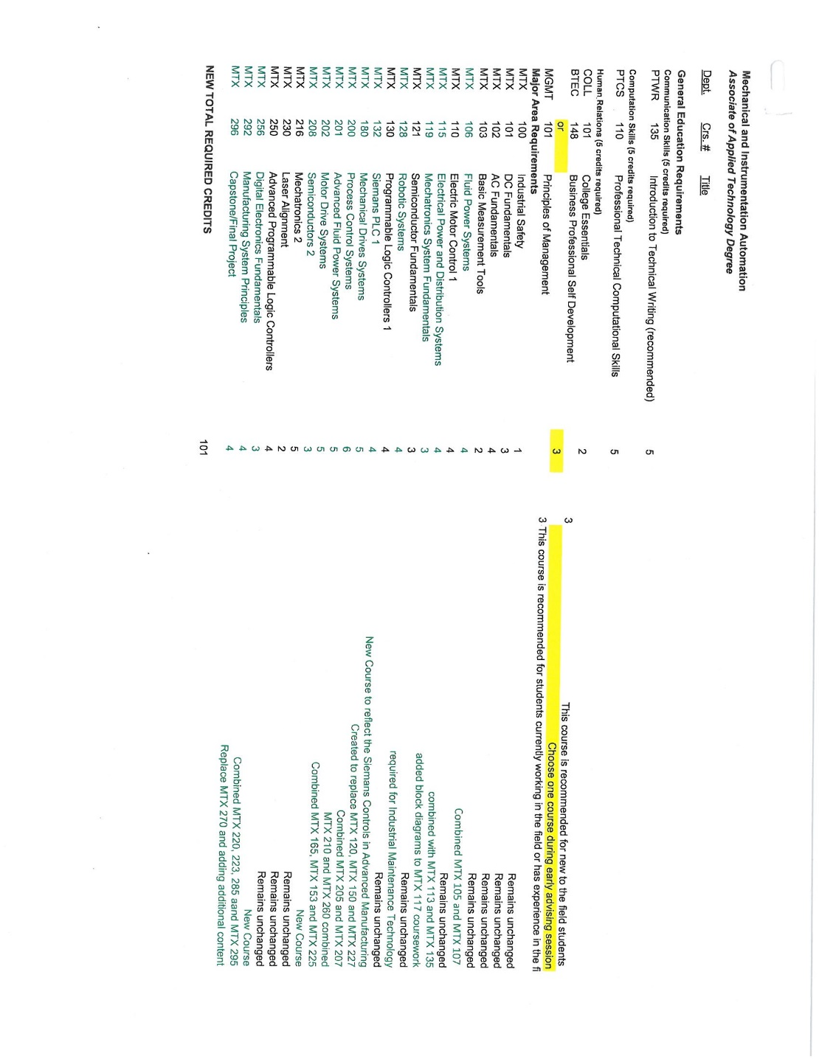

APPENDIX B

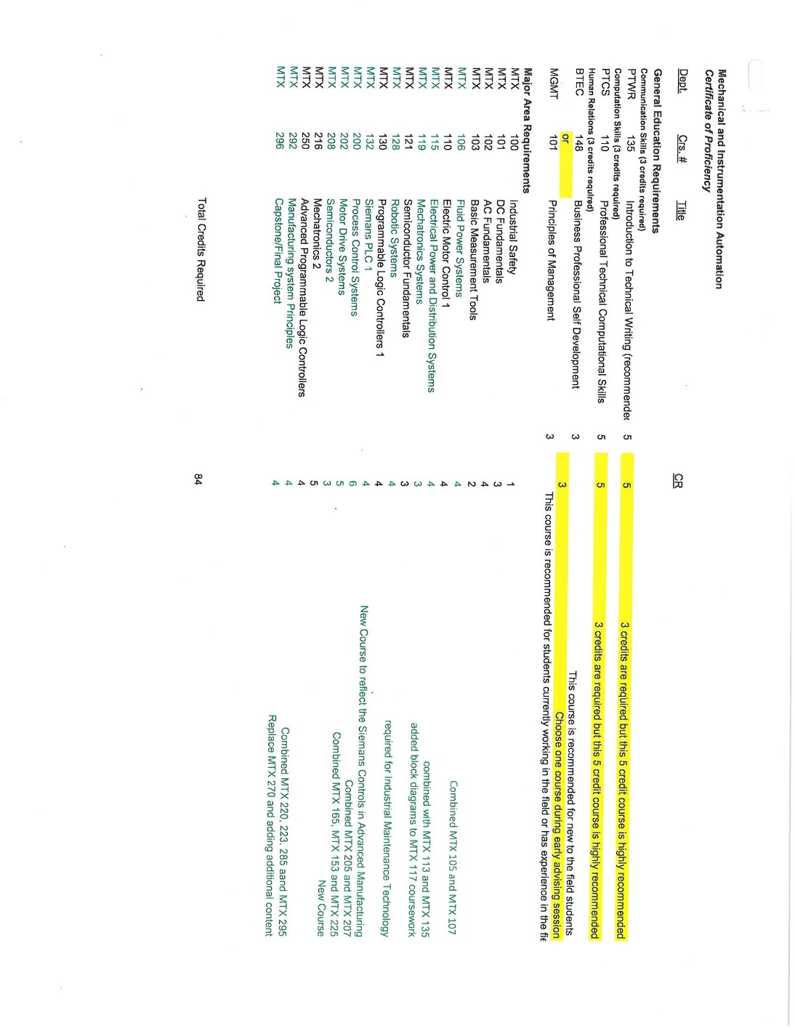

APPENDIX C

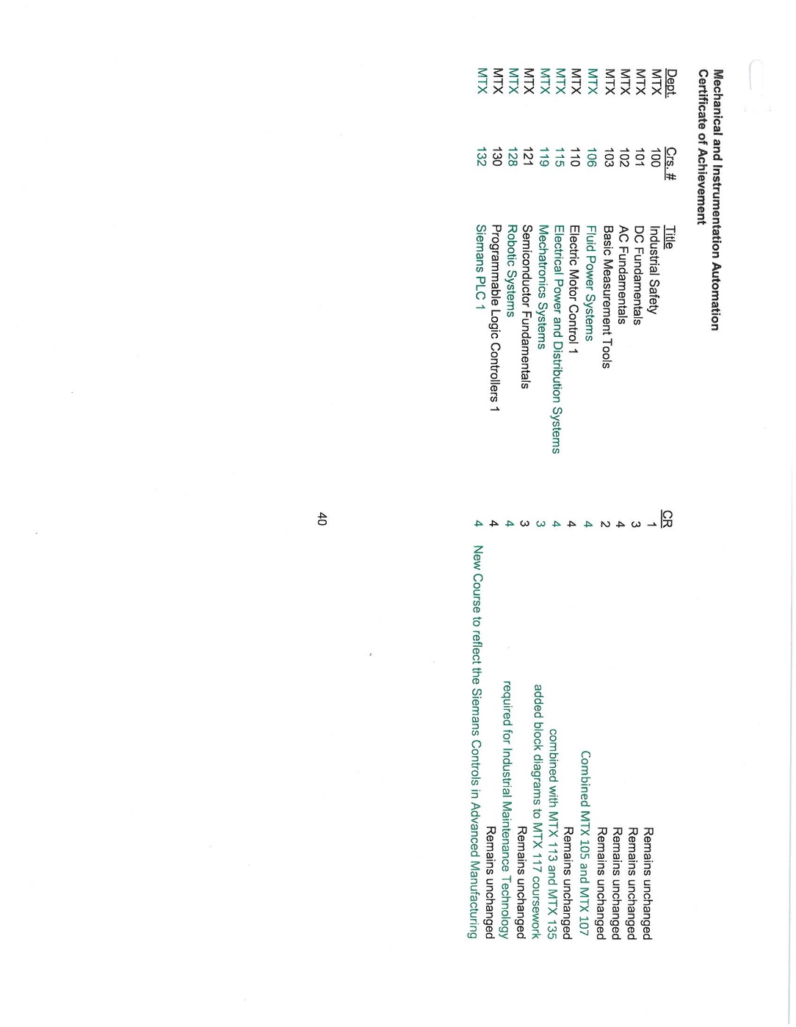

APPENDIX D

