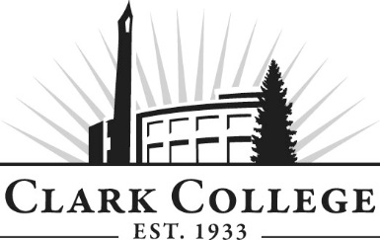

EMT ADVISORY COMMITTEE MEETING MINUTES
Tuesday, June 12, 2018 * 12:00 pm – 2:00 pm
Northwest Regional Training Center – Board Room

Members Present: Shaun Ford, North County EMS (Committee Chair); Pete Adams, Vancouver Fire Dept.; John Griffith, AMR

Members Absent: Deanna Richardson, AMR; Kendon Fisher, SphereMD; Ron Stewart, Cowlitz EMS; Paul Bennett, Camas-Washougal Fire Department; James Eagon, CRESA

Clark College: Holly Edwins, EMT Lead Instructor; Brenda Walstead, Dean of Business & Health Sciences; Shelley Ostermiller, Associate Director, Advising – Health Occupations; Heather King, BHS Unit Operations Manager

Guests: Eric Simukka, Clark County Fire District #6; Dave Sinclair, Clark County Fire District #6

Committee Chair Shaun Ford called the meeting to order at 12:04 p.m. and introductions were made.

  - Minutes of the Previous Meeting

The minutes of November 14, 2017 were presented: made a motion to approve as written; this was seconded by and passed unanimously: as a quorum was not present, the votes were sent for approval by electronic vote.
As of November 11 2017, the minutes have been approved.

  - Next Meeting Date

The committee will meet again on Tuesday, November 13, 20 (thanksgiving week), 27

  - Office of Instruction Updates

  - Proposed Paramedic Degree

  - Task Book

  - Discussion Items

Shaun adjourned the meeting at 1:40.pm
Prepared by SueAnn McWatters

