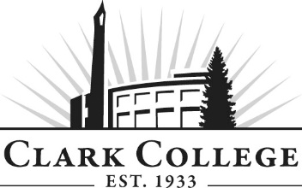

COMPUTER SUPPORT INFORMATION TECHNOLOGY ADVISORY COMMITTEE - MINUTES
Friday, May 4, 2018 * 8.30am – 10.00am
GHL 205

Members Present: Aaron Johnson, Intel (Vice Chair); Patrick Earl, MSVC USA; Ryan McCandless, Robert Half Technology; Tom Strobehn, Fastech Solutions Paul Yee, SHARP

Remote Attendance: Jeffrey Hoy, PeaceHealth (called in by phone)

Clark College: Bob Hughes, CTEC Department Head/Instructor; Adam Coleman, Bruce Elgort, Roger Zimmerman -CTEC Instructors; Bill Baker, Adjunct; April Cannon, Advising; SueAnn McWatters, Program Specialist - Advisory Committees

Committee Vice Chair Aaron Johnson called the meeting to order at 8.36am and introductions were made. Jeff Hoy attended the meeting remotely.

  - Minutes of the Previous Meeting

The minutes of October 27, 2017 were presented: Aaron made a motion to approve the minutes as written. This was seconded by Paul and passed unanimously.

  - Next Meeting Date

The committee will next meet on Friday, October 19th at 8:30am.

  - Office of Instruction Announcements

Cathy Sherick made the following announcements:

Welcome SueAnn McWatters, for those who may not have met SueAnn, she is the new Advisory Coordinator. The position was formerly held by Nicola Farron, and she started in January of this year providing meeting coordination and support to the twenty-seven Career and Technical Education Advisory Committees in addition to administrative support in the Office of Instruction. Sue Ann comes to us most recently from WSU Vancouver where she worked in the College of Business, Finance and Operations, and Development and Alumni. She is a former Clark student and graduate of WSUV, attaining a Bachelor’s in Business Administration.

Career and Technical Education Insert was sent in February, unfortunately we were not able to produce the insert as a focus on the high school partnerships as we had originally envisioned. It is however, a very nice look at our professional technical education programs and the students they serve.

Healthy Penguin Walkabout Saturday June 2, 2018, registration opens at 9:00 with the event beginning at 10. Community members and anyone interested in good health are invited to participate in this FREE event to stroll the beautiful campus and receive free health assessments.

Spring Recognition event planned for Wednesday, June 13th. The event will be held in the somewhere on campus (TBD). Our opportunity to share some refreshments and acknowledge and thank each of our community advisory members for their service to the college. Watch for a save the date, coming to your email soon.

Need for new Advisory Members we are asking our advisory members to think about others in the community that you know that might be interested in being a part of building student success at the college. Our committees are shrinking and we are in need of folks to provide that employee as well as employer perspective.

PPI Exercise and handout: Academic plan Goal 6: Infuse the study of Power, Privilege and Inequity throughout the curriculum. Last year advisory members asked why this was happening at Clark. To answer that question, we have been working with the Office of Diversity and Equity to put together some basic information to share with everyone.

Enrollment

Dwight stated that the program is holding steady with 65-75 students. There are double the students going into the certificate. It will be interesting what happens next year when the program rebrands with a one year IT skills certificate.

  - Computer Support

AAS vs. AAT

Dwight explained that the program is going to change from Computer Support AAS to Computer support AAT. This will replace the current Computer Support Certificate with an updated IT Skills Fundamentals course in the first year that will prepare students for a second year of sturdy and will create a “stackable” degree. There are two reasons why it changed to an AAT model:
- General pathway to a 4 year degree
- Networking/Mechatronics/Web Development are all programs in technical education that are AATs.
This provides more opportunities to give students content and information. This also follows the guided pathways model.

Curriculum Map Review
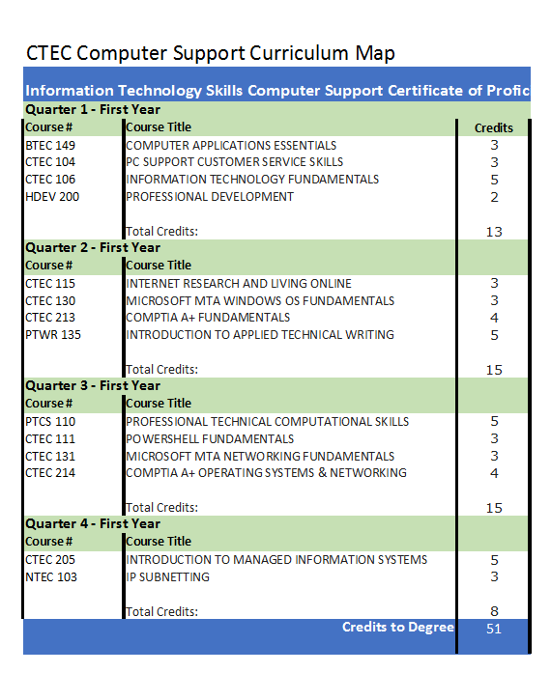
In the first year, a student can enter the program at any quarter as part of the certificate. The program is currently experimenting with the schedule for the second year. Hopefully, we will be able to stagger classes in the evening. These certificates would also be a great resume builder. Each of these classes could be directed/correlated to a certificate. Tom stated that if students completed this, they would definitely be hirable.

The committee discussed what employers look for during the hiring process. Tom mentioned that he usually asks for transcripts and then puts the applicants right into a test program to see what they know.

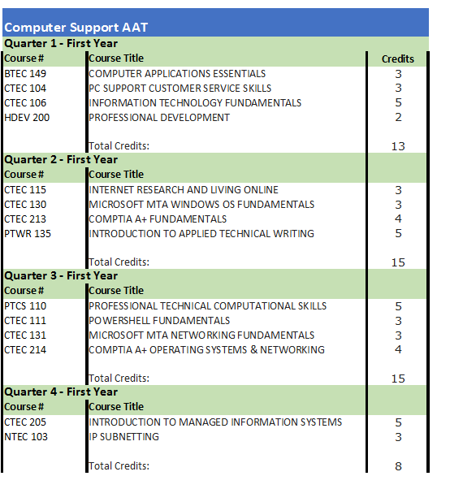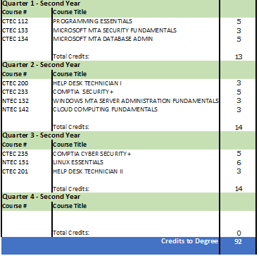

Bob proposed to call out COLL&101 for the first quarter. HDEV&200 would be held in the fourth quarter. NTEC&221 would be listed as an option instead of CTEC205 as a gateway for a second year Networking Degree for the 19-20 catalog.

Aaron motioned a vote of confidence in support of the stackable degree and decision points with a consideration of revision of the curriculum in fall (movement of COLL&101 into the first quarter and HDEV&200 into the fourth quarter). Tom seconded; and was pass unanimously by the rest of the committee.

The AAT also has a CompTIA focus which creates opportunity for potential BAS program development into Cybersecurity. There has also been very positive feedback with the new Bachelors in Cyber Security that Dwight Hughes has been working on. Hopefully NTEC and CTEC will define the paths and then students can decide between the two. This would greatly bolster the current networking degree.

  - Scholarship Development for Certifications

Bob spoke on the initiative to create scholarships for certifications. The initial goal is to have every graduate of the program have the opportunity to sit for at least one certification out of those in the curriculum. There are many programs that have certifications and this could help with not only this program, but others (automotive, welding, cuisine, networking, etc.).

The Relevant 2017 CompTIA Academy Certification Vouchers available through the Clark Bookstore:
- A+ 220-901 or 220-902 = $120.50/exam (Worker Retraining, Reboot, etc. can sometimes help with the expense of the exam)
- Network+ = $185.90
- Server+ = $185.90
- Security+ = $260.25
- Cloud Essentials = $89.75
- Cloud + = $185.90
- CSA+ = $260.25

  - Programming Course Updates

CTEC&112

Bruce discussed his experience teaching the course. This requires them to know python, java script, and html, which gives them a more well-rounded web experience. It is programming essentials; what to program, how to make functions, and grabbing data. Microsoft has added additional exams; HTML Fundamentals and Programming Essentials with Python/JavaScript, etc.). The goal is to get the students taking these two courses to be able to pass the MTA (Microsoft Technology Associate) exams.

CTEC&135

Bob mentioned that the goal of creating the CSIT program was to allow more opportunities for students to gain interest and skills set. In fall of 2018, the programs wants to offer a C# course, a Microsoft programming class. Bill Baker is the new adjunct who will teach the course.

There are a few more students on the NTEC pathway as they are interested in CISCO. However, both programs are pretty steady and even. People understand the MTA and are embracing it.

The most in demand computer languages in the world are:
- JavaScript
- Java
- PHP
- Python
- C#

  - Industry Updates

Paul mentioned that both people and jobs are moving overseas.

Bruce stated that the younger generation of employees has a lot of entitlement both professionally and scholastically. Many want the loose schedules and working from home. They don’t think they have to work and earn their way.

The meeting formally adjourned at 9:55am.

Prepared by SueAnn McWatters

