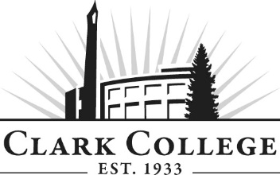
COMPUTER SUPPORT INFORMATION TECHNOLOGY ADVISORY COMMITTEE - MINUTES
Friday October 27 2017 * 8.30am – 10.00am
PUB 258C

Members Present: Aaron Johnson, Aerotek @ Intel (Vice Chair); Patrick Earl, MSVC USA; Paul Yee, SHARP
Remote Attendance: Tom Strobehn, Fastech Solutions (attended by phone)
Members Absent: Jeffrey Hoy, PeaceHealth
Guest: Anita Stepanyuk - student
Clark College: Bob Hughes, CTEC Department Head/Instructor; Adam Coleman, Bruce Elgort, Roger Zimmerman -CTEC Instructors; Genevieve Howard, Dean of WPTE; Hal Abrams, Clark College Foundation; Tina Cruz, ECD; Cathy Sherick, Associate Dir. of Instructional Planning and Innovation; Nichola Farron, Program Specialist - Advisory Committees
Committee Vice Chair Aaron Johnson called the meeting to order at 8.30am and introductions were made. Tom Strobehn attended the meeting remotely.
  - Minutes of the Previous Meeting
The minutes of April 20 2017 were presented: Aaron made a motion to approve the minutes as written. This was seconded by Paul and passed unanimously.
  - Next Meeting Date
The committee will next meet on Friday May 4 2018 at 8.30am.
  - Office of Instruction Announcements
Cathy Sherick made the following announcements:
Welcome back to 2017-18 we are excited to be rolling up our sleeves and delving in to the second year of work of our Academic plan.
The new “Areas of Study” have been adopted and approved these will provide the framework for organizing the different degree paths for students. The link is here
Advisory Committees will begin to see how they fit in to the implementation work of Pathways. The goal is to improve rates of completion, transfer and attainment of jobs. The American Association of Community Colleges (ASCC) has developed a model that articulates the implementation process. Advisory members are encouraged to review the model for understanding.
Academic plan Goal 6: Infuse the study of Power, Privilege and Inequity throughout the curriculum. Last year advisory members asked why this was happening at Clark. To answer that question, we have been working with the Office of Diversity and Equity to put together some basic information that can help frame the issue for further discussion. Watch for it on meeting agendas.
The new McClaskey Culinary Institute (MCI) is open and teaching students this term! The link to information about the program is here. We are looking forward to being able to provide our advisory members with menu items from the cuisine and baking programs.
Clark continues to see enrollment declines, which may have budget impacts. We do not anticipate further program cuts at this time, but cannot rule out the possibility of changes in the future should this trend continue. Your help in letting community members know about the great programs at Clark is appreciated!
As programs are taught out, we have terrific Advisory volunteers we hate to lose. Often we need to infuse current committees with new members, and sometimes new programs are developed that will need new advisory committees. We are working this year on the development of a Master Advisory Committee that will help us with three tasks.
- Visiting current committees to talk to members and get an idea of how things are working.
- Planning and hosting annual Advisory event.
- Reporting to the Board of Trustees every year on the great work of Advisory Committees.
Let us know if you are interested by contacting Nic. You can be on two committees, or if you want to step away from your current committee work that is fine too.
We also wanted to thank everyone who was able to attend the annual recognition event held on July 13 at the new STEM building. We had beautiful weather, many cold beverages and a great time. We look forward to planning the event next year with our new Master Advisory Committees.
We will be undertaking an updated Ethics training at the spring advisory meetings.
The annual Clark College Career fair will be held in May. Advisory Committee members will be provided additional information from the career center in upcoming meetings.
  - Elections
The Committee Chair has recently opted to resign, leaving the position open. Elections for a new Chair and Vice Chair will be held at the Spring meeting.
It is hoped that continued options for remote attendance will help to recruit members, and assist with quorum etc.
Enrollment
Bob provided an enrollment update: he was pleased to note that the program has consistent numbers between 70 to 80 students
  - High School Articulation
Bob detailed that the department has a history of articulation with local institutions, notably the Skills Center. He then detailed a new initiative by Mill A school district in Cook Co. WA called Pacific Crest Academy College in the high school. This initiative is a positive effort at serving the full geographical extents of Clark College’s service area. Bruce and Bob are working on staging the CTEC 112 programming essentials class. The scheme works by having school staff teach curriculum that is mapped to Clark; and in return, students receive college credit. Last spring the Department also re-engaged with Evergreen school district computer science faculty and advisory committee – subsequently their class will also articulate.
In response to a question from Aaron, Bob defined articulation as having comparable outcomes in a high school class as would be found in a College class, allowing a student to be awarded college credits upon completion. The student can then apply those credits towards College.
Clark County Skills Academy currently has six or seven articulated classes. Cathy thanked the program for being open to articulations and for their ongoing efforts to establish them. This is an important step in bridging the gap between high schools and College. Cathy also noted that she encourages business partners to form relationships with high schools, potentially in an advisory capacity, so that students start to learn about job and career potential in these industries.
  - Student Presentation
Student Anita Stepanyuk was welcomed by the committee: she shared that she had been able to articulate a total of 26 credits from the Skills Center to Clark College, enabling her to go to College. Subsequent success in tests made her realize she could pursue a career in the discipline. Anita has now been accepted to WG University and is working full time whilst finishing her Associates degree.
The committee members congratulated Anita on her success.
Aaron posed the question as to whether this would a reproducible story, and what methods are in place to track student success after Clark graduation. The committee discussed options around establishing metrics: Clark does not currently have a system in place for connecting with students after graduation beyond the efforts of the Alumni office. Anita stated that the Skills Center establishes a pattern of regular contact at various points: the committee felt this would be a good model to emulate.
Bob also spoke about the importance of access to certification that Anita had throughout her studies: industry recognized certificates are increasingly valuable for students in adding attractiveness to their resume. The program currently gives students the ability to earn six MTA certificates and the CompTIA IT fundamentals as part of their coursework. This is currently funded through student lab fees, but there is an increasing shortfall to cover the higher-level certificates, which have to be covered by students on their own.
Hal spoke to the committee about the potential for local businesses and community partners to establish scholarship funds for students to help cover the certification costs associated with the program. He invited committee members to connect with the Foundation to investigate how they could help students entering their industry.
  - Curriculum Updates
Bob referenced previous committee discussions about the direction of the program with the potential for a shift from AAS to AAT; and the changing of the current support certificate to an IT Skills Fundamentals certification (approved at the April 2017 meeting) at 52 credits. Other changes were the addition of CTEC 115, and the replacement of command line CTEC 111.The consensus was that it is important to have a focus on security, so CTEC 133 security class has a stronger role in the first year. As such, the first year of the AAT degree is established, and the second year will have A+, security and networking.
In reference to the growing emergence of security-based skills in the industry, combined with the potential for a 4-yesar degree in cyber security currently being explored at Clark, the committee made the following changes:
- Deactivating Computer Support Certificate of Proficiency
Aaron made a motion to support, which was seconded by Tom and passed unanimously Tom seconded all in favor
- Addition of CTEC 233, 235 and 201 to the second year of the degree.
Aaron’s motion was seconded by Patrick and was passed unanimously.
The committee then had a lengthy discussion about degree structure, which was sent for electronic review following the meeting, to allow time for members to consider their response to the proposed following degree structures which would include the replacement of the AAS with the AAT format:
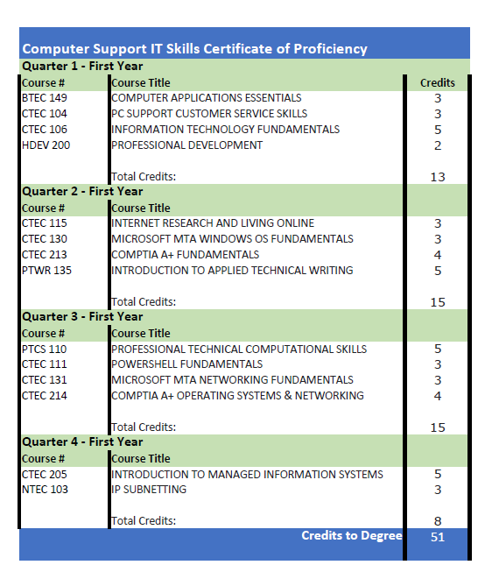
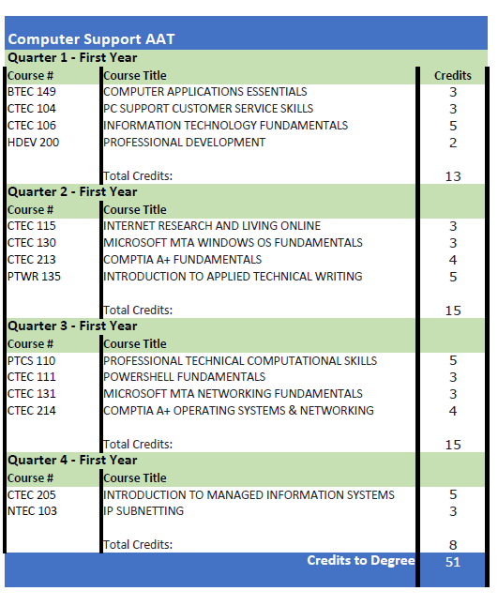
As of October 31 2017, these degree structures were approved by the committee.
The meeting formally adjourned at 10.05am.
Prepared by Nichola Farron

