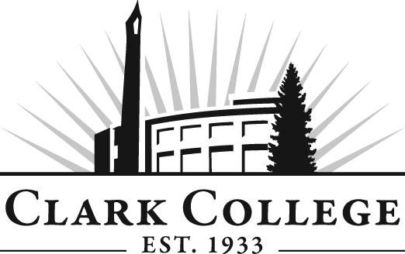
Culinary Arts Advisory Committee
Meeting Agenda
Date: Tuesday, May 12, 2015
Time: 2:30—4:30 p.m.
Meeting Location: Gaiser Dining Room

Agenda Item | Expected Outcome | Time
- Call Meeting to Order – Committee Chair | N/A
- Welcome and Introductions – Committee Chair | New members/guests introduced | 5 min.
- Approval of Minutes from Last Meeting – Chair  - January 13, 2015 | Corrections indicated and/or approval of minutes as written. | 5 min.
- Office of Instruction Updates- Advisory Committee Business-  - Advisory Breakfast recap  - Fall chair/vice chair training  - Clark College Strategic Plan |  | 10 min.
- Director/division chair Report |  | 5 min.
- Work Plan-Committee Chair and Program Director/Division Chair  - Remodel & curriculum development | Implement strategies as outlined in work plan. If necessary, identify work groups. | 50 min.
- Old Business-Follow-up- Committee Chair |  | 10 min.
- New Business | New business items are addressed by the committee. | 10 min.
- Summary of follow-up action items – Committee Chair | Summary of follow-up actions communicated to the committee. | 5 min.
- Industry report – All members |  | 15 min.
- Establish next meeting date and adjournment – Committee Chair | Meeting date established. | 5 min.

