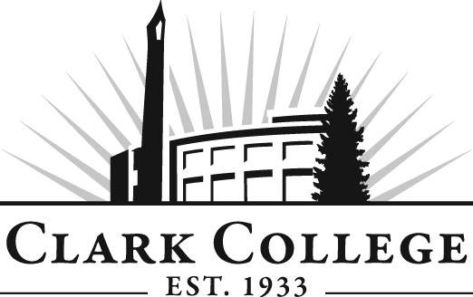
Culinary Arts Advisory Committee
Meeting Agenda
Date: Tuesday, January 13, 2015
Time: 2:30 pm
Meeting Location: Gaiser Dining Room

Agenda Item | Expected Outcome | Time
- Call Meeting to Order – Committee Chair | N/A
- Welcome and Introductions – Committee Chair | New members/guests introduced | 5 min.
- Approval of Minutes from Last Meeting – Chair  - April 23, 2014 | Corrections indicated and/or approval of minutes as written. | 5 min.
- Office of Instruction Updates- Advisory Committee Business-  - Perkins & Worker Retraining Grant awards  2014-15  - Credit for Prior Learning—program launch  - Committee website/Updated Advisory Committee Handbook/Chair & Vice Chair contact info  - Committee roster  - Review of by-laws/attendance  - Advisory Committee Recognition event – Weds., March 18, 2015, 7:30 a.m. – 9:00 a.m. Regional economist Scott Bailey will be guest speaker |  | 15 min.
- Director/division chair Report  - Remodel update/Facility drawing & timeline |  | 30 min.
- Work Plan-Committee Chair and Program Director/Division Chair | Implement strategies as outlined in work plan. If necessary, identify work groups. | 10 min.
- Old Business-Follow-up- Committee Chair |  | 10 min.
- New Business-Committee Chair  - Curriculum Development; Direction of Culinary Program | New business items are addressed by the committee. | 20 min.
- Reports from industry-committee members |  | 15 min.
- Summary of follow-up action items – Committee Chair | Summary of follow-up actions communicated to the committee. | 5 min.
- Establish next meeting date and adjournment – Committee Chair | Meeting date established. | 5 min.

