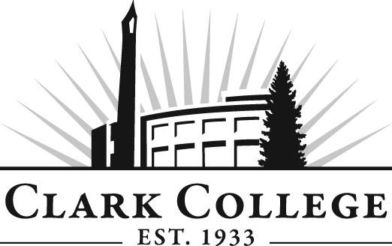
Business Administration Advisory Committee
Meeting Agenda
Date: Tuesday, April 21, 2015
Time: 4:30—6:30 p.m.
Meeting Location: Penguin Union Building, Room 258B

Agenda Item | Expected Outcome | Time
- Call Meeting to Order – Committee Chair | N/A
- Welcome and Introductions – Committee Chair | New members/guests introduced | 5 min.
- Approval of Minutes from Last Meeting – Chair  - January 20, 2015 | Corrections indicated and/or approval of minutes as written. | 5 min.
- Office of Instruction Updates- Advisory Committee Business-  - Advisory Breakfast recap  - Fall Training  - Clark College Strategic Plan |  | 10 min.
- Director/division chair Report |  | 15 min.
- Work Plan-Committee Chair and Program Director/Division Chair  - BAS update  - K-12 update  - Vision 20/20-review list to implement in fall  - Endowment – update  - Student club – funding | Implement strategies as outlined in work plan. If necessary, identify work groups. | 40 min.
- Old Business-Follow-up- Committee Chair  - Standardize number of students for each course  - Non-profit business course - progress  - Marijuana business course – progress |  | 10 min.
- New Business | New business items are addressed by the committee. | 20 min.
- Summary of follow-up action items – Committee Chair | Summary of follow-up actions communicated to the committee. | 5 min.
- Establish next meeting date and adjournment – Committee Chair – 2nd Tuesday after quarters begin. | Oct. 6, 2015  Jan. 19, 2016  April 19, 2016 | 5 min.

