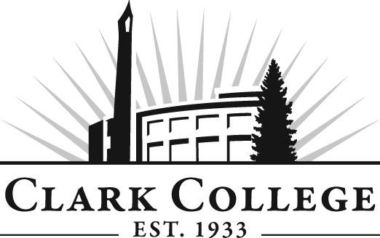
Addiction Counselor Education Advisory Committee
Meeting Agenda
Date: Friday, July 24, 2015
Time: 9:00—1:00 am
Meeting Location: Hanna Hall, room 117

Agenda Item | Expected Outcome | Time
- Call Meeting to Order – Committee Chair | N/A
- Welcome and Introductions – Committee Chair | New members/guests introduced | 5 min.
- Approval of Minutes from Last Meeting – Chair  - April 24, 2015 | Corrections indicated and/or approval of minutes as written. | 5 min.
- Office of Instruction-Cathy Sherick  - Ethics training  - OOI updates |  | 15 min.
- Director/division chair Report |  | 15 min.
- Work Plan-Committee Chair and Program Director/Division Chair | Implement strategies as outlined in work plan. If necessary, identify work groups. | 30 min.
- Old Business-Follow-up- Committee Chair  - Recovery Coach curriculum & pathway  - Recruitment at NW Recovery Project  - Recovery Coach grant proposal for Lifeline Connections  - Submission of ACED 170 credit increase to curriculum in fall term |  | 30 min.
- New Business  - Proposal-Guest Brian Schooner | New business items are addressed by the committee. | 10 min.
- Summary of follow-up action items – Committee Chair | Summary of follow-up actions communicated to the committee. | 5 min.
- Establish next meeting date and adjournment – Committee Chair | Meeting date established. | 5 min.

