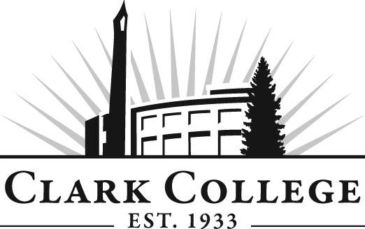
Addiction Counselor Education Advisory Committee
Meeting Agenda
Date: Friday, April 24, 2015
Time: 1:00—3:00 p.m.
Meeting Location: Hannah Hall, Room 117

Agenda Item | Expected Outcome | Time
- Call Meeting to Order – Committee Chair | N/A
- Welcome and Introductions – Committee Chair | New members/guests introduced | 5 min.
- Approval of Minutes from Last Meeting – Chair  - January 30, 2015 | Corrections indicated and/or approval of minutes as written. | 5 min.
- Office of Instruction Updates-Advisory Committee Business-  - Advisory Breakfast recap  - Fall Training  - Clark College Strategic Plan |  | 10 min.
- Director/division chair Report |  | 15 min.
- Work Plan-Committee Chair and Program Director/Division Chair-- | Implement strategies as outlined in work plan. If necessary, identify work groups. | 40 min.
- Old Business-Follow-up- Committee Chair  - Recovery Coaches—curriculum, need, where are we?  - Sabbatical—when  - Field placement update  - Diversity statistics for students enrolled in the program | Information shared  Plan of action | 10 min.
- New Business  *Sabbatical—what does the committee do while our fearless leader is out? Form a Plan  *Have there been any requests by ACED students for “credit for prior learning?” | New business items are addressed by the committee. | 20 min.
- Summary of follow-up action items – Committee Chair | Summary of follow-up actions communicated to the committee. | 5 min.
- Establish next meeting date and adjournment – Committee Chair | Meeting date established. | 5 min.

