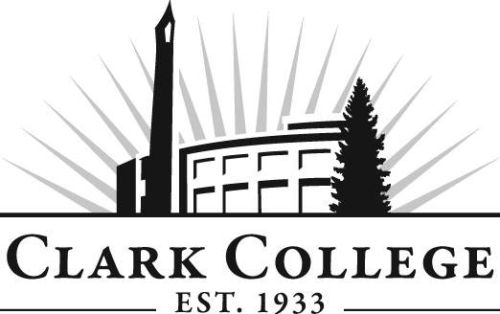
Addiction Counselor Education Advisory Committee
Meeting Agenda
Friday 22nd April 2016: 11.30am-1.30pm
Hanna Hall, room 121

Agenda Item | Expected Outcome
- Call Meeting to Order – Committee Chair | N/A
- Welcome and Introductions – Committee Chair | New members/guests introduced
- Approval of Minutes from Last Meeting – Chair  - January 29 2016 | Corrections indicated and/or approval of minutes as written.
- Office of Instruction Updates – Cathy Sherick

- Director/Division chair Report
• Update: Rickey’s Law.
• Update: status of offering the CDP exam here on campus.

- Work Plan-Committee Chair and Program Director/Division Chair | Implement strategies as outlined in work plan. If necessary, identify work groups.
- Old Business-Follow-up- Committee Chair  • Jim Jensen: information regarding Recovery Schools  • Ratification of the city University articulation agreement: committee requested additional information  • Discussion of employer’s survey concerning a BAS for the program  • Update: status of recovery coaches and credentialing | - Revisit items that were not discussed previously due to time constraints  - Provide updates
- New Business  - Nomination of Nichole Laverne for membership to the committee from the Salvation Army residential treatment center  - Nomination proposal from Chris Thompson | New business items are addressed by the committee.
- Summary of follow-up action items – Committee Chair | Summary of follow-up actions communicated to the committee.
- Establish next meeting date and adjournment – Committee Chair | Meeting date established.

