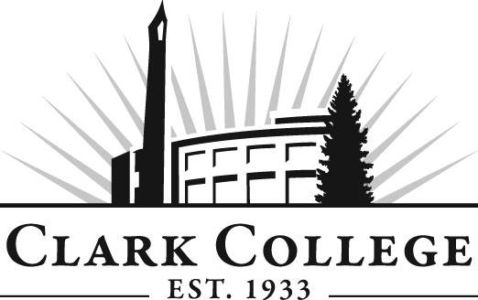
Addiction Counselor Education Advisory Committee
Meeting Agenda
Friday, January 29, 2016
Meeting Location: Hanna Hall, room 117

Agenda Item | Expected Outcome | Time
- Call Meeting to Order – Committee Chair | N/A
- Welcome and Introductions – Committee Chair | New members/guests introduced | 5 min.
- Approval of Minutes from Last Meeting – Chair  - September 25, 2015 | Corrections indicated and/or approval of minutes as written. | 5 min.
- Director/Division chair Report |  | 15 min.
- Work Plan-Committee Chair and Program Director/Division Chair | Implement strategies as outlined in work plan. If necessary, identify work groups. | 40 min.
- Old Business-Follow-up- Committee Chair  - Update on Recovery Coach training  - Update on BAS |  | 10 min.
- New Business | New business items are addressed by the committee. | 20 min.
- Summary of follow-up action items – Committee Chair | Summary of follow-up actions communicated to the committee. | 5 min.
- Establish next meeting date and adjournment – Committee Chair | Meeting date established. | 5 min.

