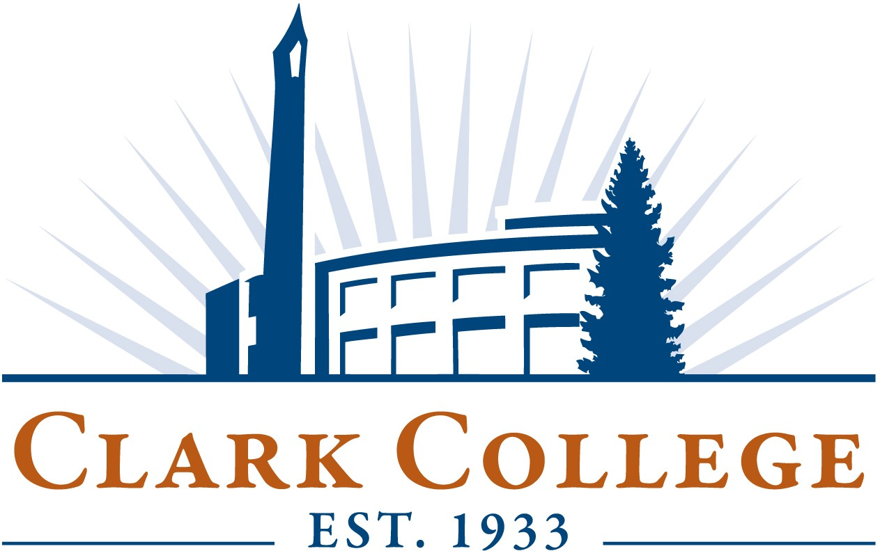

Clark College BOT Executive Session
Friday, June 28, 2019 4:30 PM (PDT)
Baird Room 102
(President's Conference Room)

Clark College BOT Executive Session
Friday, June 28, 2019 4:30 PM (PDT)
Baird Room 102
(President's Conference Room)

- Call to Order - Chair Jacobsen
- Executive Session
Pursuant to RCW 42.30.110(1)(g) to review the performance of a public employee.
- Adjournment - Chair Jacobsen

